UNITED  NATIONS |  |  | SC
 |  | UNEP/POPS/COP.2/INF/17
 | United Nations  Environment  Programme | Distr.: General  22 February 2006  English only
Conference of the Parties of the Stockholm Convention
on Persistent Organic Pollutants
Second meeting
Geneva, 1–5 May 2006
Item 5 (g) of the provisional agenda∗
Matters for consideration or action by the Conference of the Parties:
Technical assistance

Compilation of submissions received by the Secretariat on the terms of reference for the regional and subregional centres for capacity-building and transfer of technology∗

Note by the Secretariat

- In developing the terms of reference for regional and subregional centres and criteria for evaluating the performance of such centres, the Secretariat, pursuant to paragraph 1 (a) of decision SC-1/16, invited Stockholm Convention focal points, existing regional and subregional centres and their host organizations providing technical assistance and technology transfer for chemicals and chemical waste issues to provide comments on the subject matter.
- In response to that invitation, the Secretariat received submissions from the following Parties to the Convention: Brazil, Czech Republic, Morocco and Slovakia. Submissions were also received from the Governments of Guinea and Kazakhstan, the Basel Convention regional centres in Slovakia and Egypt, the African Regional Office of the Food and Agriculture Organization of the United Nations (FAO), the secretariat of the Basel Convention and the secretariat of the Pacific Regional Environment Programme (SPREP).
- Those submissions have been reproduced as received in the annex to the present note.
Annex

A. Submissions by Parties

Brazil
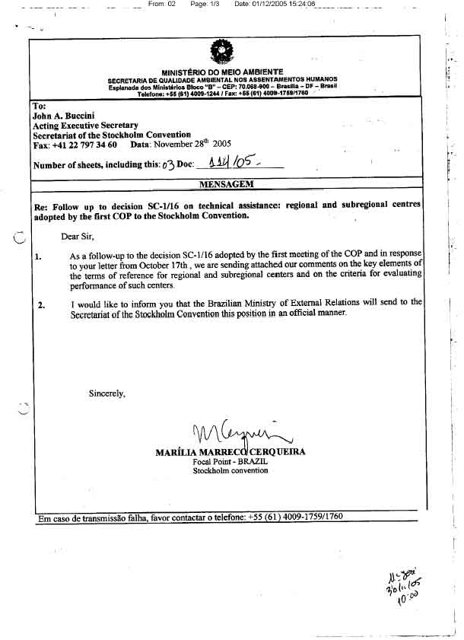
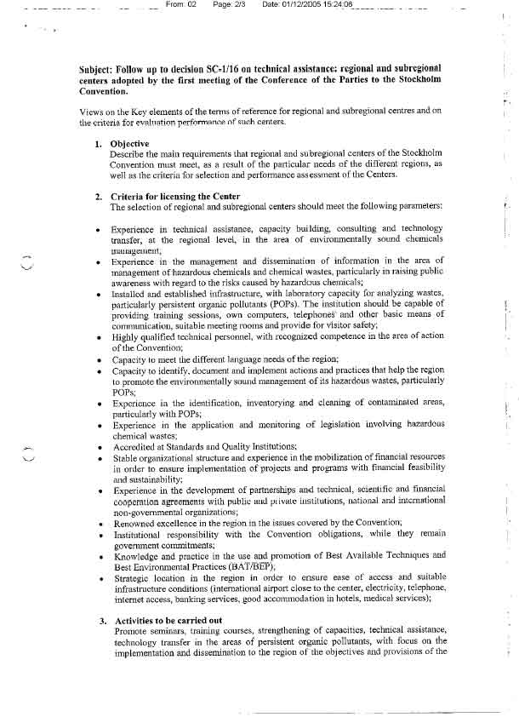
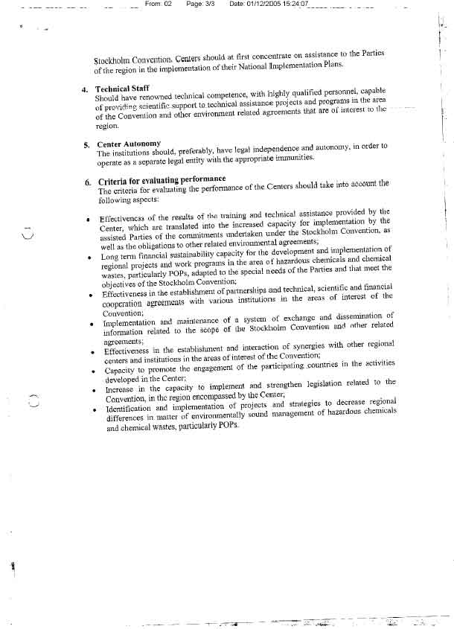

Czech Republic
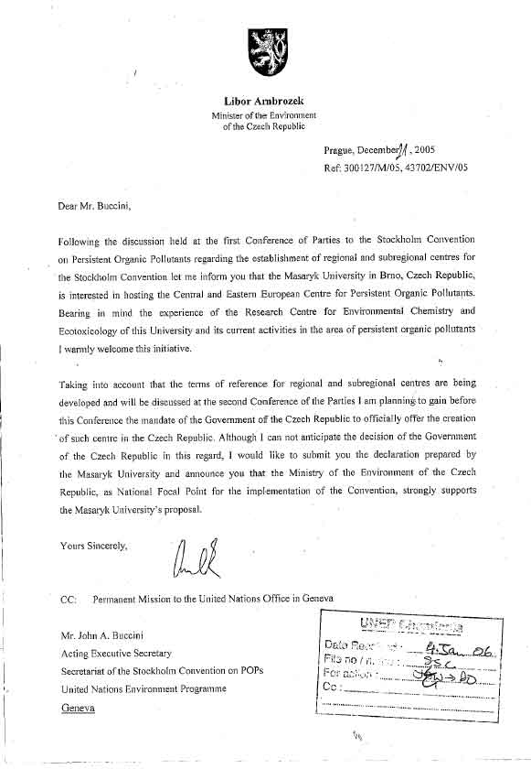

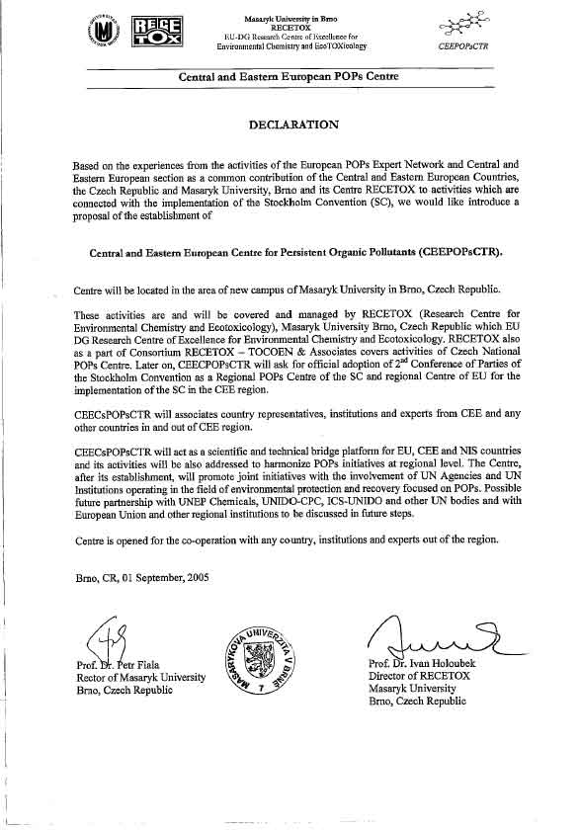
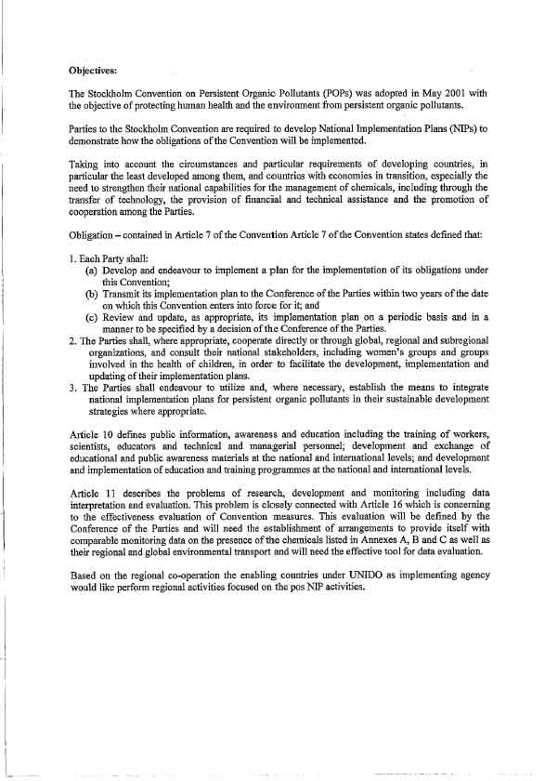

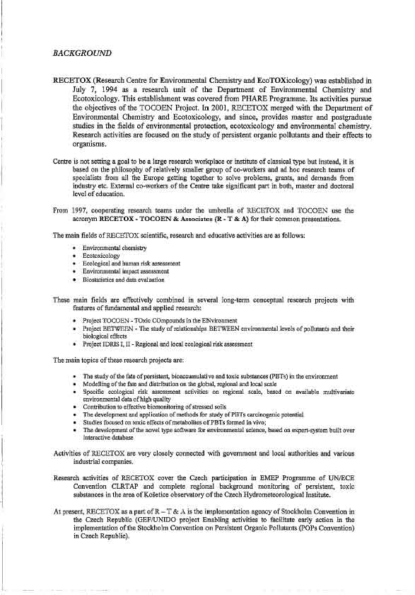
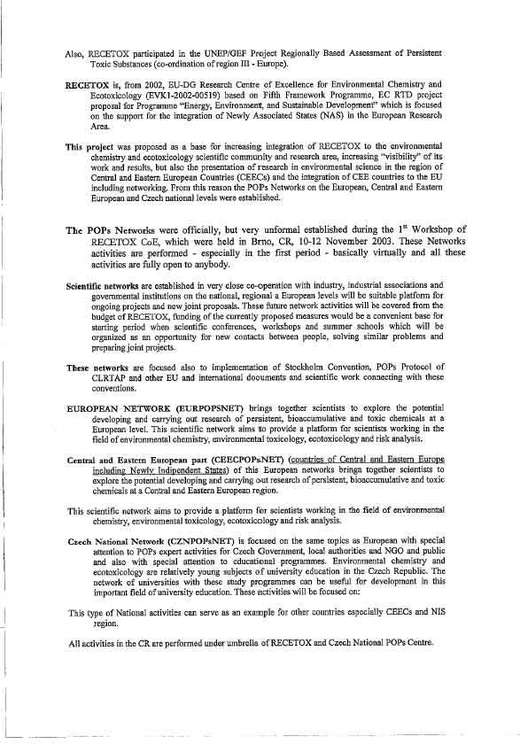
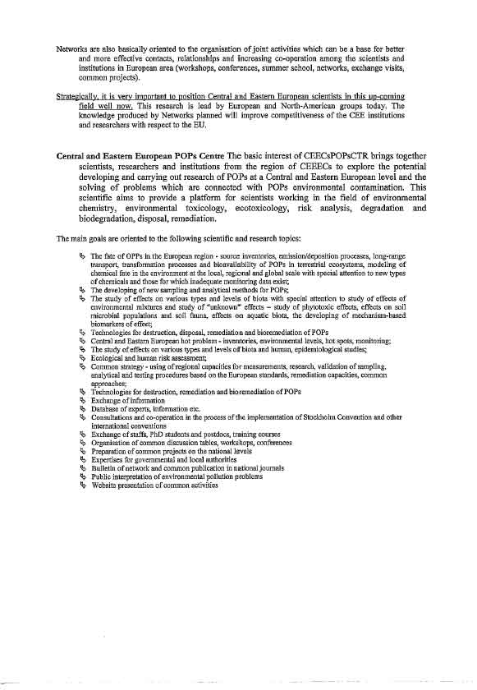
Morocco

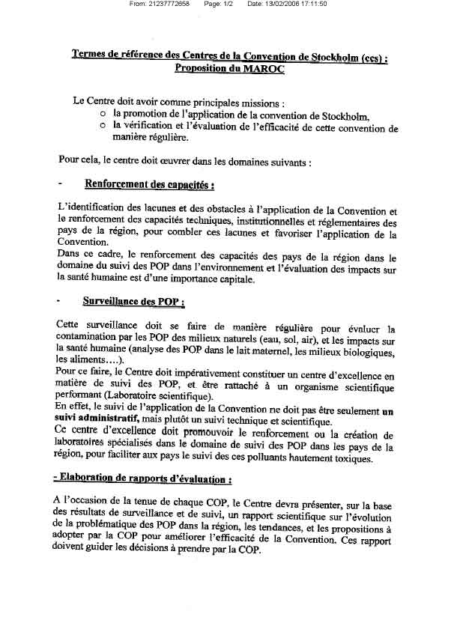
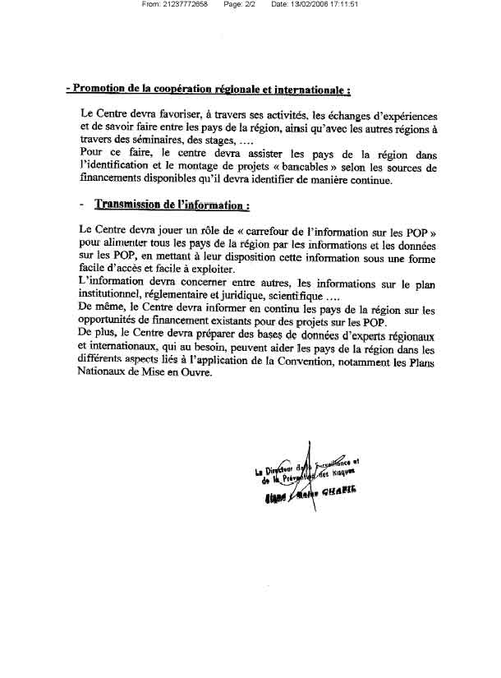
Slovakia
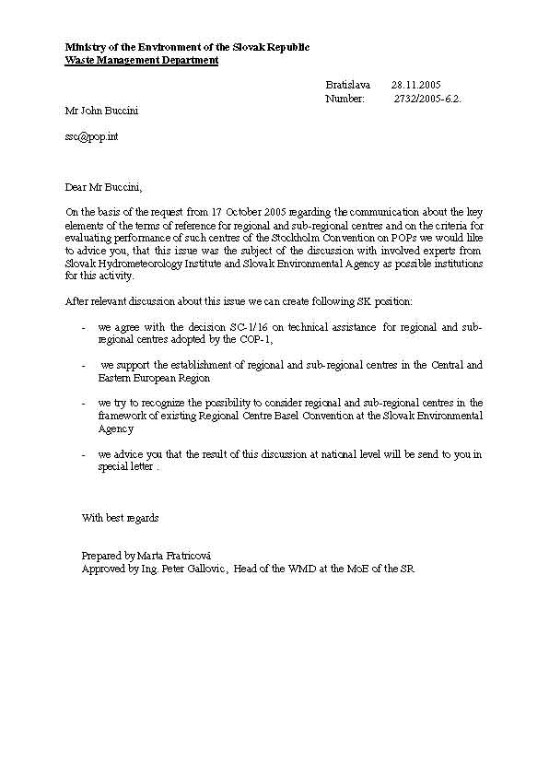

B. Other submissions

Guinea

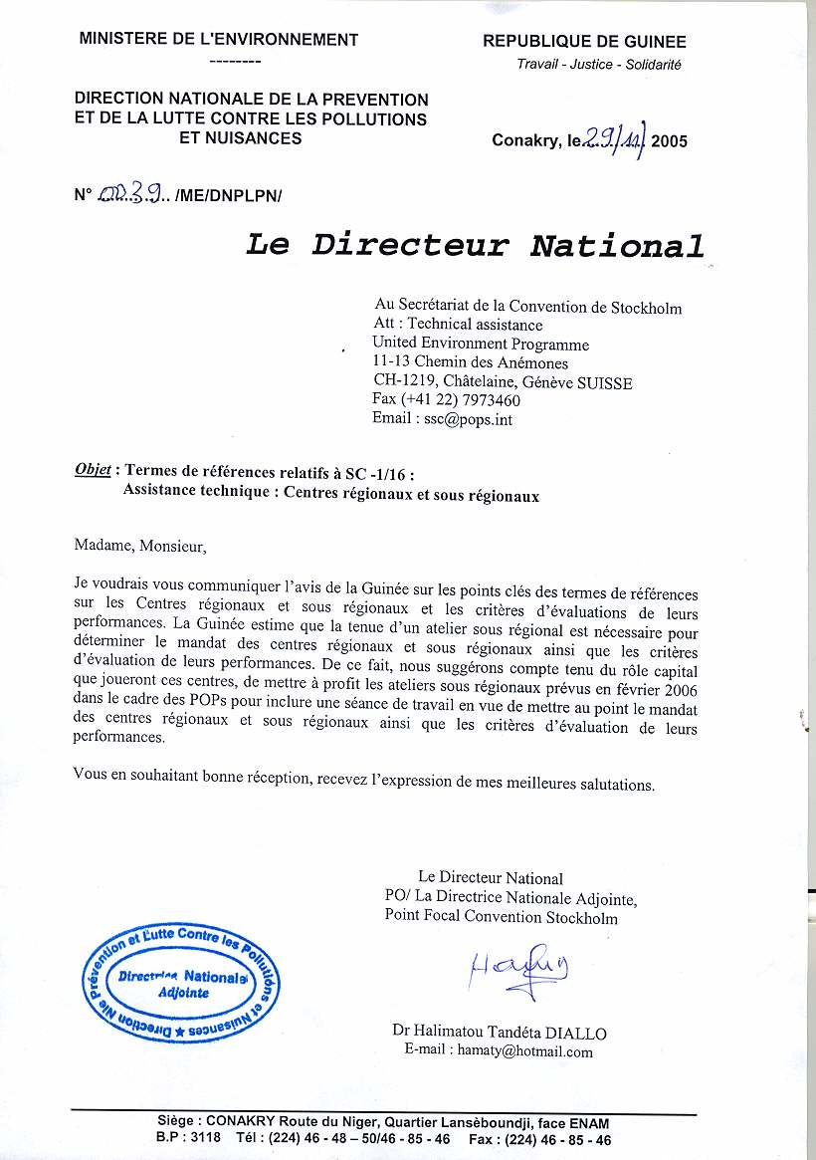
Kazakhstan 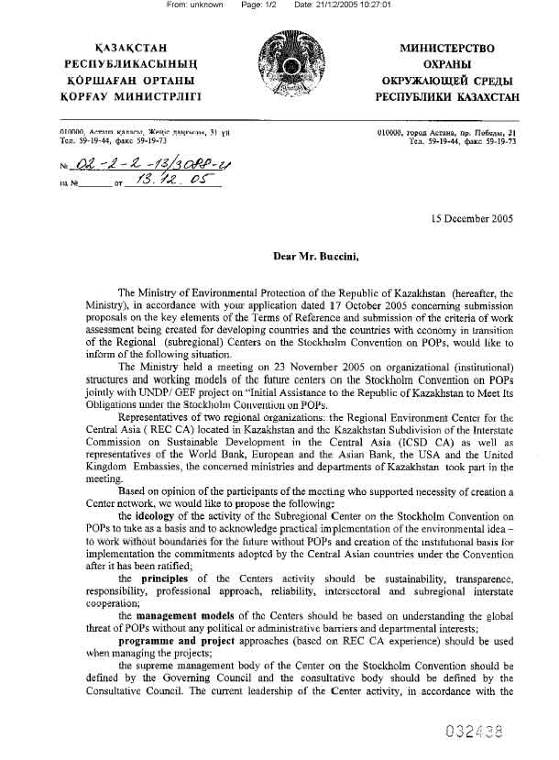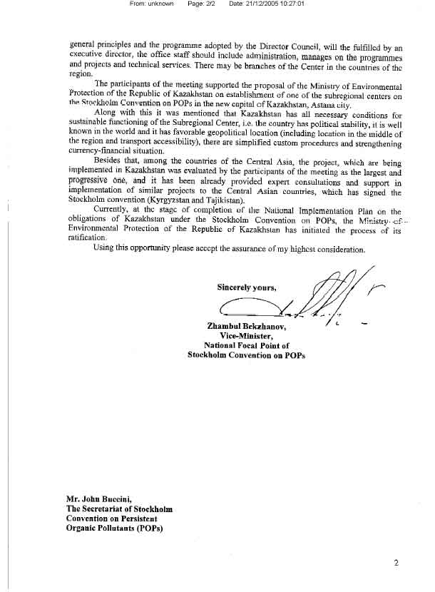

Basel Convention Regional Centre in Slovakia
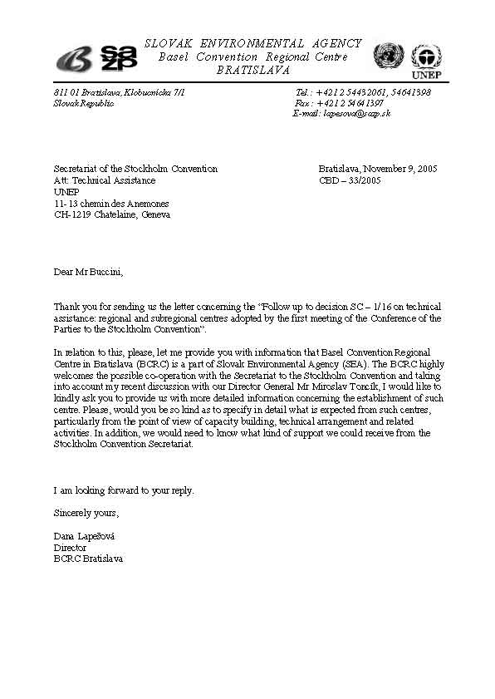
Basel Convention Regional Centre in Cairo

Sent to: Secretariat of the Stockholm Convention
At: Technical Assistance
United Nations Environment Programme
11-13 chemin des Anemones
CH-1219, Chatelaine, Geneva, Switzerland
Fax: (+41 22) 797 34 60
E-mail: ssc@pops.int
John A. Buccini
Acting Executive Secretary

Subject: Follow up to decision SC-1/16 on technical assistance: regional and sub-regional centers adopted by the first meeting of the Conference of the Parties to the Stockholm Convention.

Dear Mr. John A. Buccini

As requested to BCRC-Cairo to provide its experience to develop terms of reference for regional and sub-regional centers and criteria for evaluating the performance of such centers, within a framework of a process to synthesize information that may serve as a methodological note for drafting TORs for establishing Stockholm Convention Regional Centre(s), the following issues are worth mention:.

Issues related to the candidate country (ies) for hosting the proposed centre

Having considered the country’s proposals and identification of portfolio of initiatives for
development of Stockholm Convention Regional Centre(s) (SCRC), it is important to develop terms of references (TOR) covering the different aspects of administrative, technical, and geographic and/or political situations of the countries serviced by such centers. The purpose of these TOR should provide countries parties to SC with some requirements (human, physical and financial) for establishing such regional centers on specific thematic areas taking into consideration that the potentialities of the countries to start the process of launching (SCRC) are not at the same level, depending on the political and economical situation. The possible involvement of existing Basel Convention Regional Centers (BCRC) and use of their expertise into the process of establishing (SCRC) is, therefore, very important.
In this respect BCRC-Cairo recognizes the following:
- . The candidate country (ies) should take a lead in planning and implementing SC activities in close cooperation with other members counties serviced by the proposed regional centre.
- The candidate country (ies) should allow membership to all interested Parties of the region ignoring any possible political obstacles, and through designated institution(s)/organization(s) will develop scientific cooperation and promote dynamic interaction among the members countries and relevant agencies.
- The candidate country (ies) shall consult and cooperate to prepare, as appropriate, in accordance with relevant regional implementation of SC, sub-regional and/or regional action programmes to harmonize, complement and increase the efficiency of national programmes and ensure concrete outcomes from activities to be undertaken by the proposed centre.
- The candidate country (ies) shall explore the possibilities of identifying activities on scientific and technical cooperation in the priority areas pertaining to SC and the possibilities of promoting exchange of technologies

Issues related to the entity of the proposed regional centre

- The proposed SCRC should be an existing training centre, with the necessary equipment for conducting presentations and seminars (conference room with computer and/or overhead projection) and should have a good telecommunication infrastructure and availability of basic services and technical devices including telephones, fax, photocopier, printer and Internet connections with service providers. The proposed SCRC should also have logistical facilities (accommodation possibilities, travel agency support etc..)
- The proposed (SCRC) should be coordinated by an institution designated for that purpose i.e. ministries of environment or environmental affairs agencies and should cooperate closely with relevant intergovernmental and non-governmental organizations to avoid duplication of efforts.
- It is expected that the (SCRC) to be established will provide or arrange for qualified and experienced technical working group available to conduct training sessions and facilitate the organization of workshops, seminars, and study tours relevant to the SC
- The trainers should have a good knowledge of the English language, both oral and written and provide training for scientific, technical and management personnel and other stakeholders with a view to harmonizing programmes and to organizing exchanges of experience among them. Experience is also necessary in dealing with human resources and multicultural aspects.
- The sphere of activities of (SCRC) may include the preparation and implementation of projects; research and studies; collection, analysis and dissemination of data and information; capacity building, education and public awareness; the transfer, acquisition, adaptation and development of technology; and training.
- Other activities may also include the following:
(I) Consolidating existing knowledge, both from within and outside the region;
(ii) Establishing links among researchers and practitioners in the development and
application of innovative methodologies and approaches; and
(iii) Contributing to capacity building and strengthening the ability of government
research and service agencies throughout the region in the crucial area.
- The proposed (SCRC) should have a secretariat of qualified personnel in documentation, information and networking, both professional and general staff with good knowledge/fluency/ of English language, oral and written. Competencies should include: Internet, Word, Excel, PowerPoint etc. and knowledge of automated information systems as applied to libraries and/or information networks.
- The proposed (SCRC) should design its own information policy on the base of the national information legislation and focus its efforts on planning activities to assure the rapid and interactive exchange of information with institutions of the region in the specific thematic area and will distribute information upon request where possible in a respective format: hard or electronic.
- The proposed (SCRC) should build up a dynamic information database and web site and prepare newsletters and publications and keep updated a list of members and international partners.
- A (SCRC) on a specific thematic area should serve as an information" node” for all members parties. It is expected the database that would be established by the (SCRC) would provide information on available sources of information in the selected thematic area and will provide linkages with other information directories and databases, national libraries, depository libraries, scientific and research institutes, university libraries, digital libraries, and full-text databases to optimize the exchange of information, hard and electronic copies of publications, reports, dissertations, specialized documentation etc.
- The proposed (SCRC) will establish linkages with regional reference centers such as (BCRC) and other regional thematic host institutions on the same thematic area in order to efficiently coordinate training sessions and to locate personnel who are ready and able to conduct the training.
- Establish a coordination committee or steering committee composed of representatives of some or all country Party concerned, to review progress in the regional centre activities.
- The proposed (SCRC) should have the ability to mobilize financial resources in close cooperation with other members' parties.
Issues related to financial sustainability
- It is proposed that it will be the responsibility of the (SCRC) to mobilize resources and political support for its activities. The (SCRC) might seek financial inputs and partnership from the various special agencies of the UN system such as GEF, UNEP, NEPAD , and contributions in kind from bodies within the private sector, European Commission, NGOs, and the national and international research institutions to reach optimum functioning.
- Members Parties shall seek full use and continued qualitative improvement of all national, bilateral and multilateral funding sources and mechanisms, using consortia, joint programmes and parallel financing, and shall seek to involve private sector and mechanisms, including those of nongovernmental organizations
- The SC Secretariat may, at the request, provide a supporting role in assisting development of project proposals and facilitate and explore related opportunities, possibilities and ideas for funding such projects.
- The proposed (SCRC) should have a long-term financial planning to make the best use of the financial resources available and turn them towards financial sustainability; and mechanisms to increase its own fund-raising activities.
- Ensure resources for sustainable employment of the technical working group and secretariat stuff.

My Best Regards
Prof. M.M. El Aref
BCRC_Cairo
Director
Cairo University, Egypt
elaref@baselegypt.org
African Regional Office of FAO

Original Message-----
From: Baeta, Rosemary (FAORAF) [mailto:Rosemary.Baeta@fao.org]
Posted At: 10 November 2005 16:29
Posted To: SSC
Conversation: PL 31/2 -Invitation to provide views on Stockholm ConventionRegional and Subregional Centres
Subject: RE: PL 31/2 -Invitation to provide views on Stockholm ConventionRegional and Subregional Centres
Importance: High
Dear Mr. Buccini

Thank you for your letter dated 18 October 2005, requesting views of my Organization on the TORs of the Stockholm Convention Centres.

Having read through the decision concerning the Regional and Sub-Regional Centres, is not immediately obvious why there is a need for the centres and the purpose they would serve. Given the limited resources available, it is not clear why the additional requirements of the Stockholm Convention could not be accommodated within one or more of the existing offices that fall within the purview of UNEP.

We further note that one of the major challenges faced by the centres is how to secure financial assistance for projects while maintaining support for the structure of the centre.

Best regards.

Yours sincerely

Oloche Anebi Edache
Assistant Director-General/Regional Representative for Africa

Secretariat of the Basel Convention

From: Clara.GUZMAN@unep.ch
Posted At: Friday, December 02, 2005 3:55 PM
Conversation: Follow up to decision SC-1/16 on technical assistsance:
regional andsubregional centres adopted by the first meeting of the
Conference of theParties to the Stockholm Convention
Posted To: SSC

Subject: Follow up to decision SC-1/16 on technical assistsance:
regional andsubregional centres adopted by the first meeting of the
Conference of theParties to the Stockholm Convention

Importance: High

Further to Mr. Buccini's correspondance of 17 October 2005 inviting the Secretariat to provide its views on terms of reference, please find such input in the annex.

Best regards,

Pierre Portas
Deputy Executive Secretary
Secretariat of the Basel Convention

(See attached file: PORTAPORTASSSC Technical assistance_regional centres Nov 2005.doc)

(See attached file: PORTAS Decision VI 3.pdf)

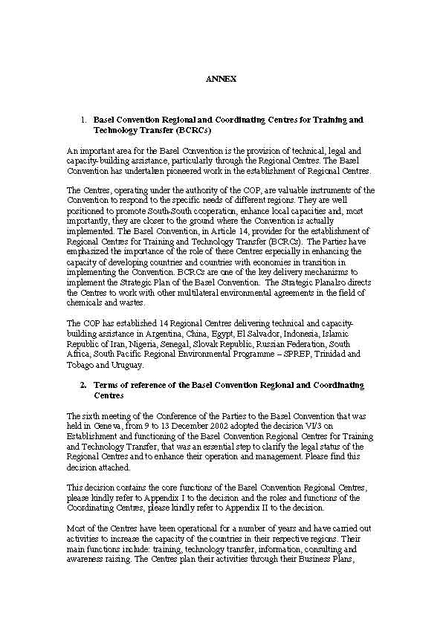

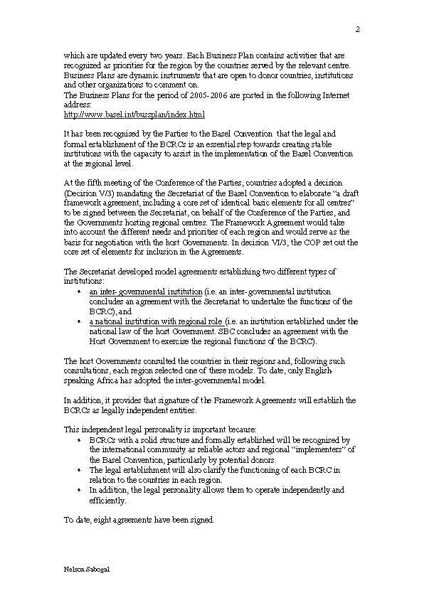



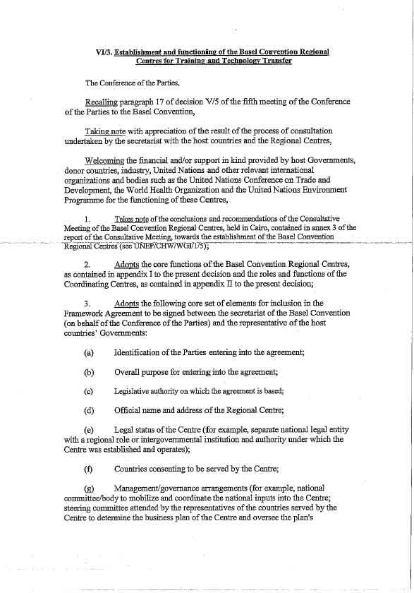



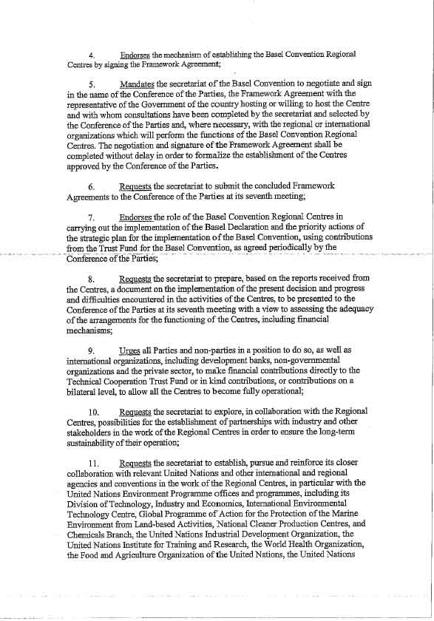



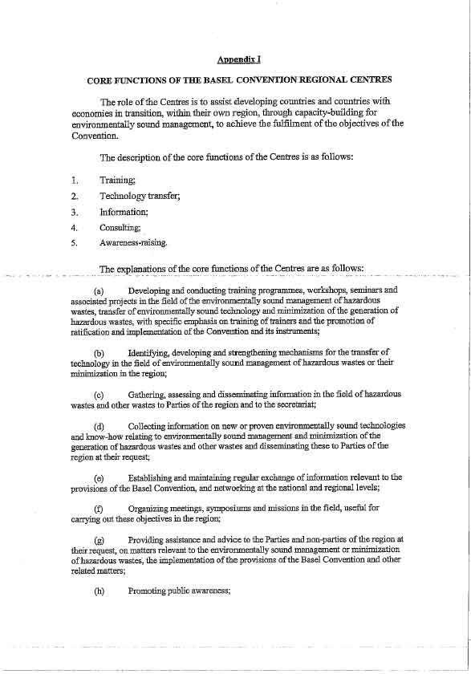
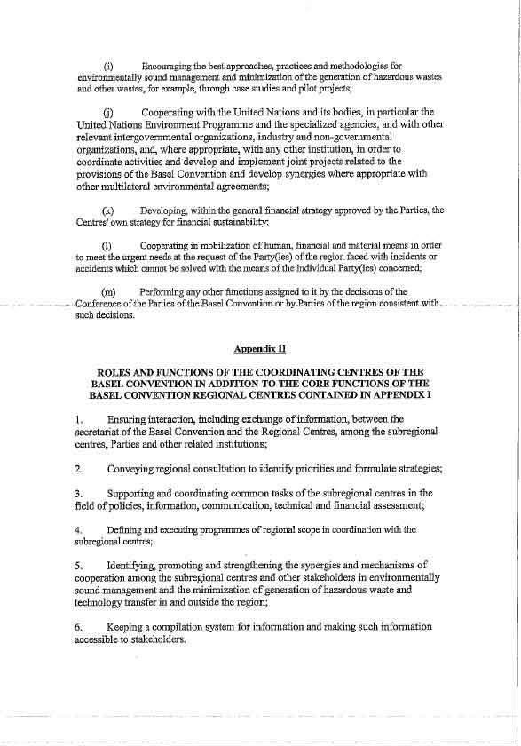
Secretariat of the Pacific Regional Environment Programme
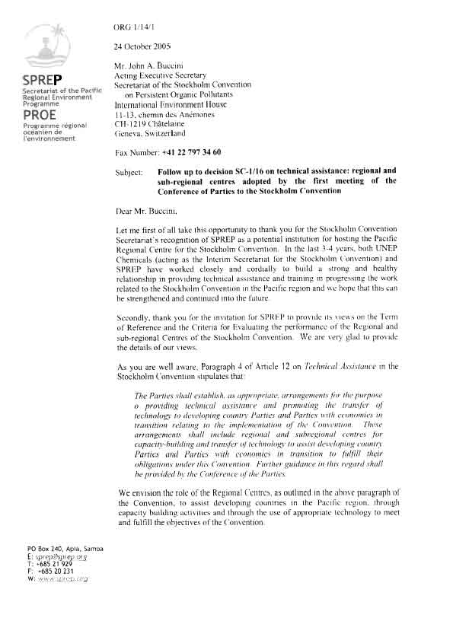
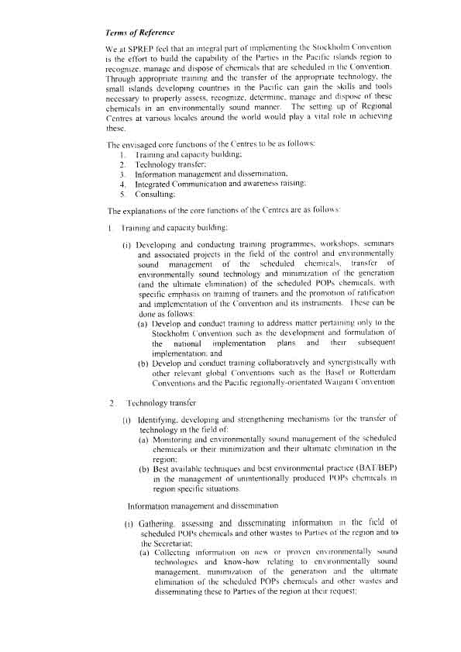
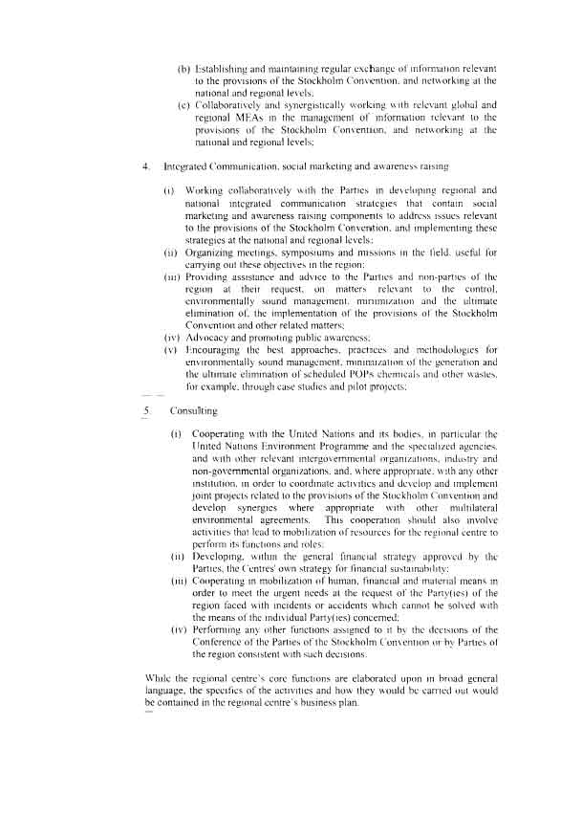
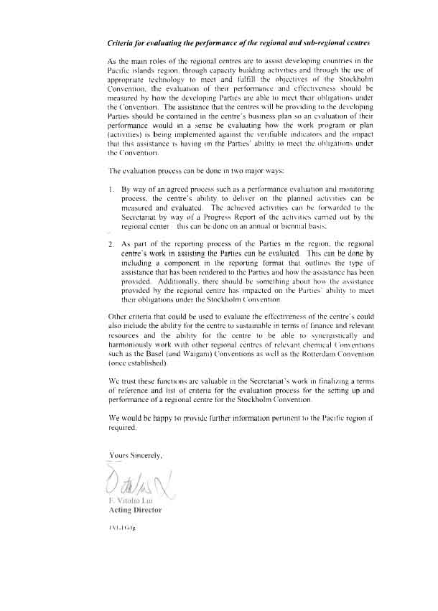
_______________

 UNEP/POPS/COP.2/1.
∗ Stockholm Convention, Article 12, paragraph 4; report of the Conference of the Parties of the Stockholm Convention on Persistent Organic Pollutants on the work of its first meeting (UNEP/POPS/COP.1/31), annex I, decision SC-1/16.

