UNITED  NATIONS |  |  | SC
 |  | UNEP/POPS/COP.3/INF/18
 | United Nations  Environment  Programme | Distr.: General  5 March 2007  English only

Conference of the Parties of the Stockholm
Convention on Persistent Organic Pollutants
Third meeting
Dakar, 30 April–4 May 2007
Item 6 of the provisional agenda*
Activities of the Secretariat and adoption of the budget

Concerns about the scale of contributions **
Note by the Secretariat

- As noted in paragraph 17 of document UNEP/POPS/COP.3/27, entitled “Activities of the Secretariat and budget for 2008 and 2009”, the annex to the present note contains:
- A letter dated 23 June 2005 to Mr. Jean Ping, President of the fifty-ninth session of the United Nation General Assembly, from Mr. Mariano Arana, the then President of the Conference of the Parties of the Stockholm Convention;
- A letter dated 29 January 2007 to Mr. Maged Younes, acting Executive Secretary of the Stockholm Convention, from Ms. Mya Than, acting Secretary, United Nations Committee on Contributions.
- The letter to Mr. Younes refers to a response by the Committee on Contributions to a similar query made by the President of the Conference of the Parties to the Rotterdam Convention. That response is contained in annex I to the Rotterdam Convention document UNEP/FAO/RC/COP.3/INF/7, which is available at www.pic.int.
Annex

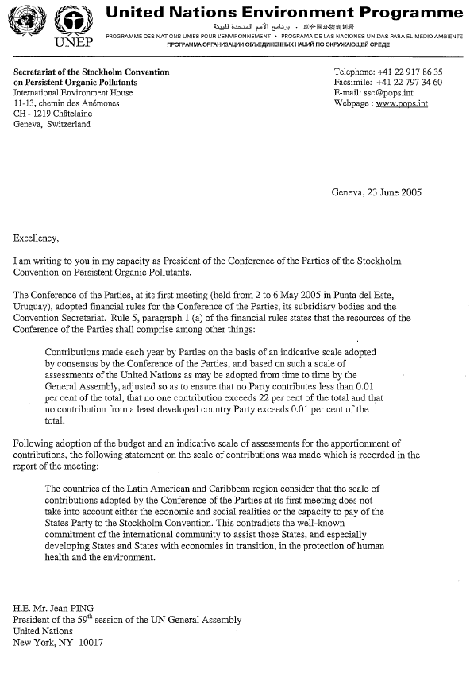

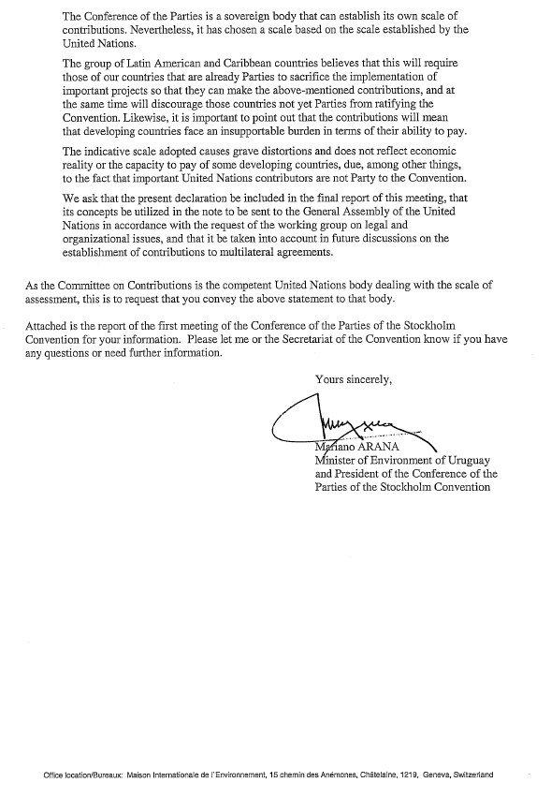

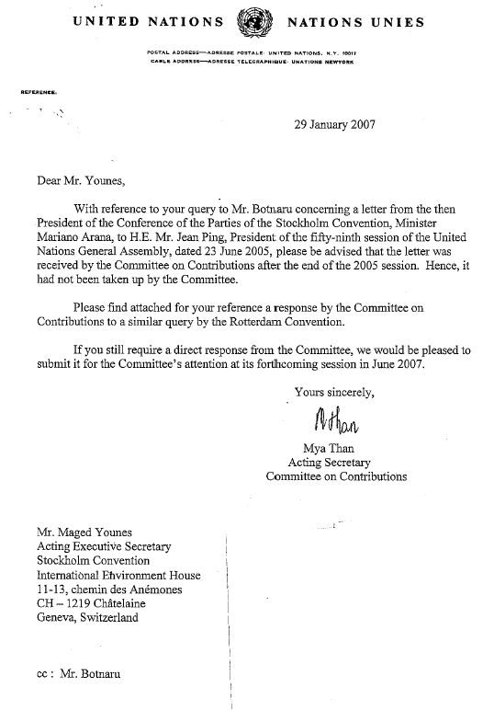

______________________

* UNEP/POPS/COP.3/1.
** Report on the work of the Conference of the Parties of the Stockholm Convention on Persistent Organic Pollutants at its first meeting (UNEP/POPS/COP.1/31), annex I, decision SC-1/4 and at its second meeting (UNEP/POPS/COP.2/30) annex I, decision SC-2/1.

