UNITED  NATIONS |  |  | SC
 |  | UNEP/POPS/COP.3/INF/20
 | United Nations  Environment  Programme | Distr.: General  28 February 2007  English only

Conference of the Parties of the Stockholm
Convention on Persistent Organic Pollutants
Third meeting
Dakar, 30 April–4 May 2007
Item 5 (e) of the provisional agenda*
Matters for consideration or action by
the Conference of the Parties: listing chemicals
in Annexes A, B or C of the Convention

Persistent Organic Pollutants Review Committee: nominee to replace a member who could not complete her term of office**
Note by the Secretariat
As noted in paragraph 11 of document UNEP/POPS/COP.3/12, entitled “Persistent Organic Pollutants Review Committee: relevant developments for action by the Conference of the Parties”, the annex to the present note contains the curriculum vitae of Ms. Liselott Säll, who has been nominated by the Government of Norway to be a member of the Persistent Organic Pollutants Review Committee to replace Ms. Janneche Utne Skare, who was not able to complete her term of office.

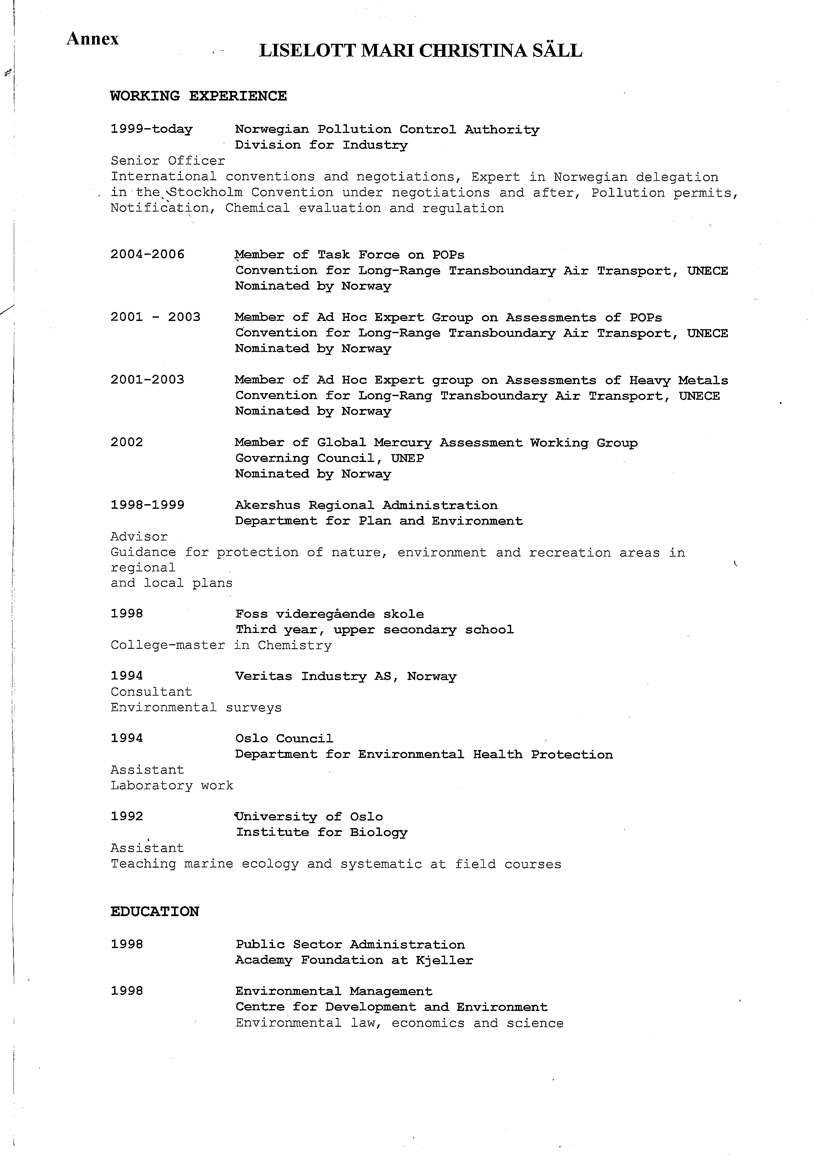
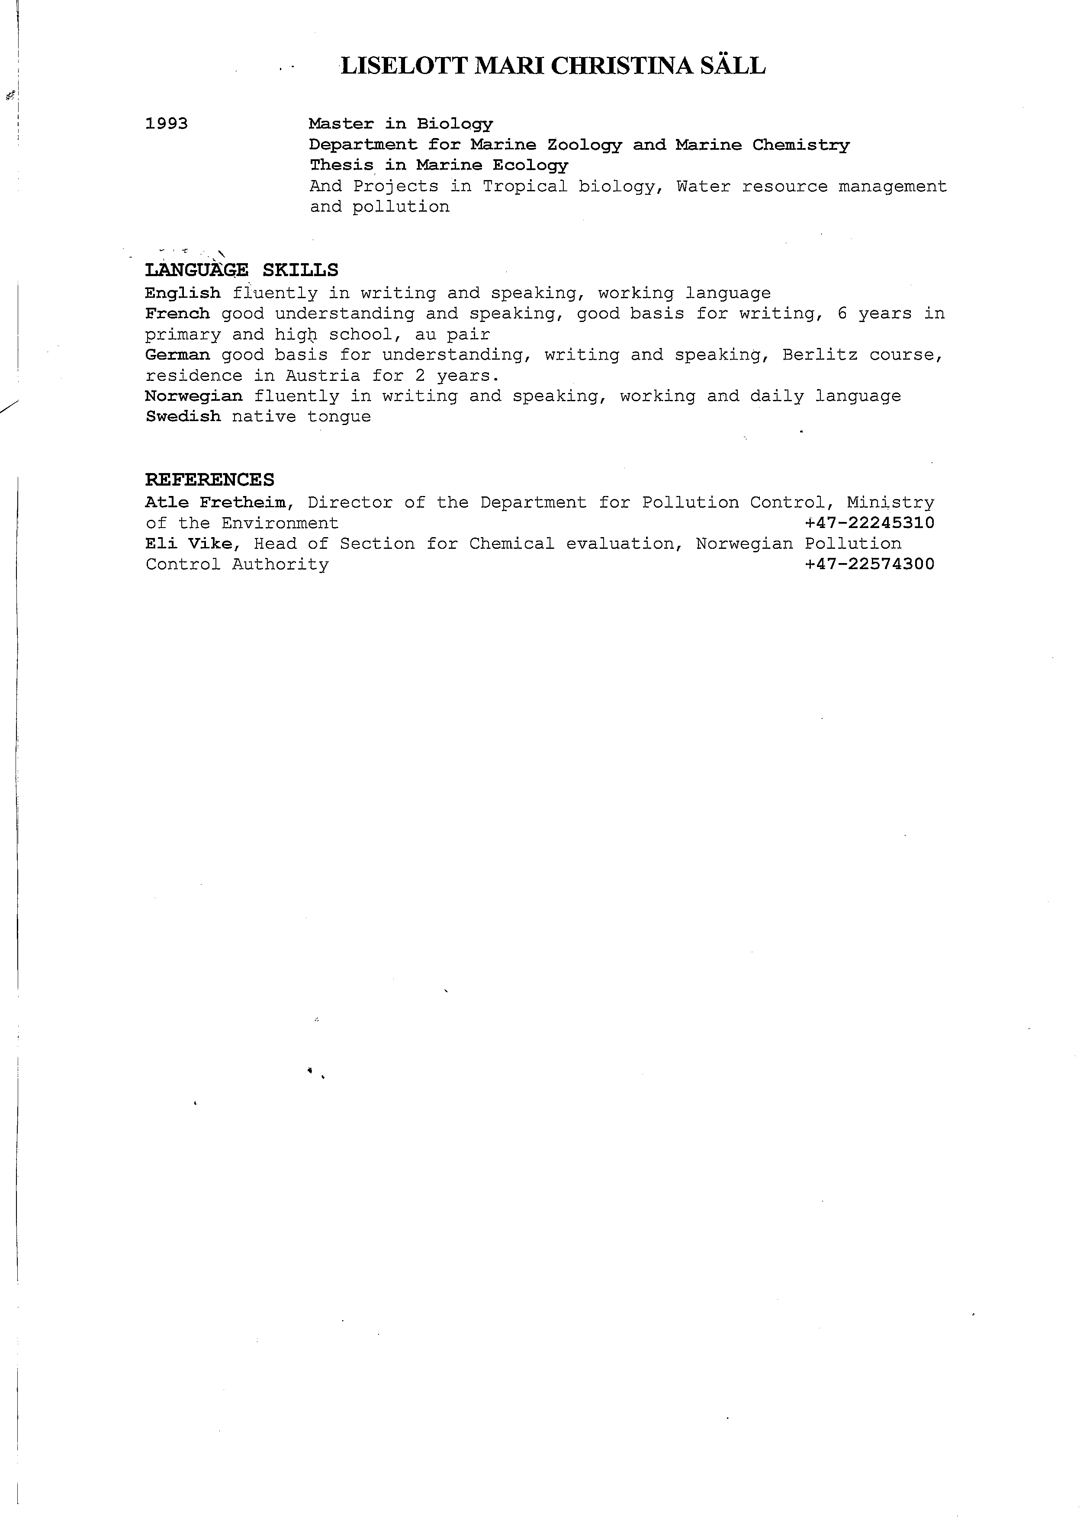

* UNEP/POPS/COP.3/1.
** Stockholm Convention on Persistent Organic Pollutants, Article 19, paragraph 6; reports on the work of the Conference of the Parties at its first meeting (UNEP/POPS/COP.1/31), annex I, decision SC-1/7 and on the work at its second meeting (UNEP/POPS/COP.2/30), annex I, decision SC-2/8.

