UNITED  NATIONS |  |  | SC
 |  | UNEP/POPS/COP.3/INF/23
 | United Nations  Environment  Programme | Distr.: General  28 February 2007  English only

Conference of the Parties of the Stockholm
Convention on Persistent Organic Pollutants
Third meeting
Dakar, 30 April–4 May 2007
Item 5 (h) of the provisional agenda*
Matters for consideration or action by the
Conference of the Parties: financial resources

Compilation of submissions received by the Secretariat on views on the further elaboration of the terms of reference for work on assessment of funding needs**
Note by the Secretariat

- By paragraph 5 of its decision SC-2/12, adopted at its second meeting, the Conference of the Parties invited Parties and other Governments, on the basis of the terms of reference set forth in the annex to decision SC-2/12, to submit to the Secretariat by 31 October 2006 views on further elaboration of the terms of reference on work on assessment of funding needs for Parties that are developing countries or Parties that with economies in transition to implement the provisions of the Convention over the period 2006–2010.
- In response to that invitation the Secretariat received submissions from the following Parties to the Convention: Antigua and Barbuda, Burundi, China and Slovakia. These submissions have been reproduced in the annex to the present note without formal editing.
Submission by Antigua and Barbuda
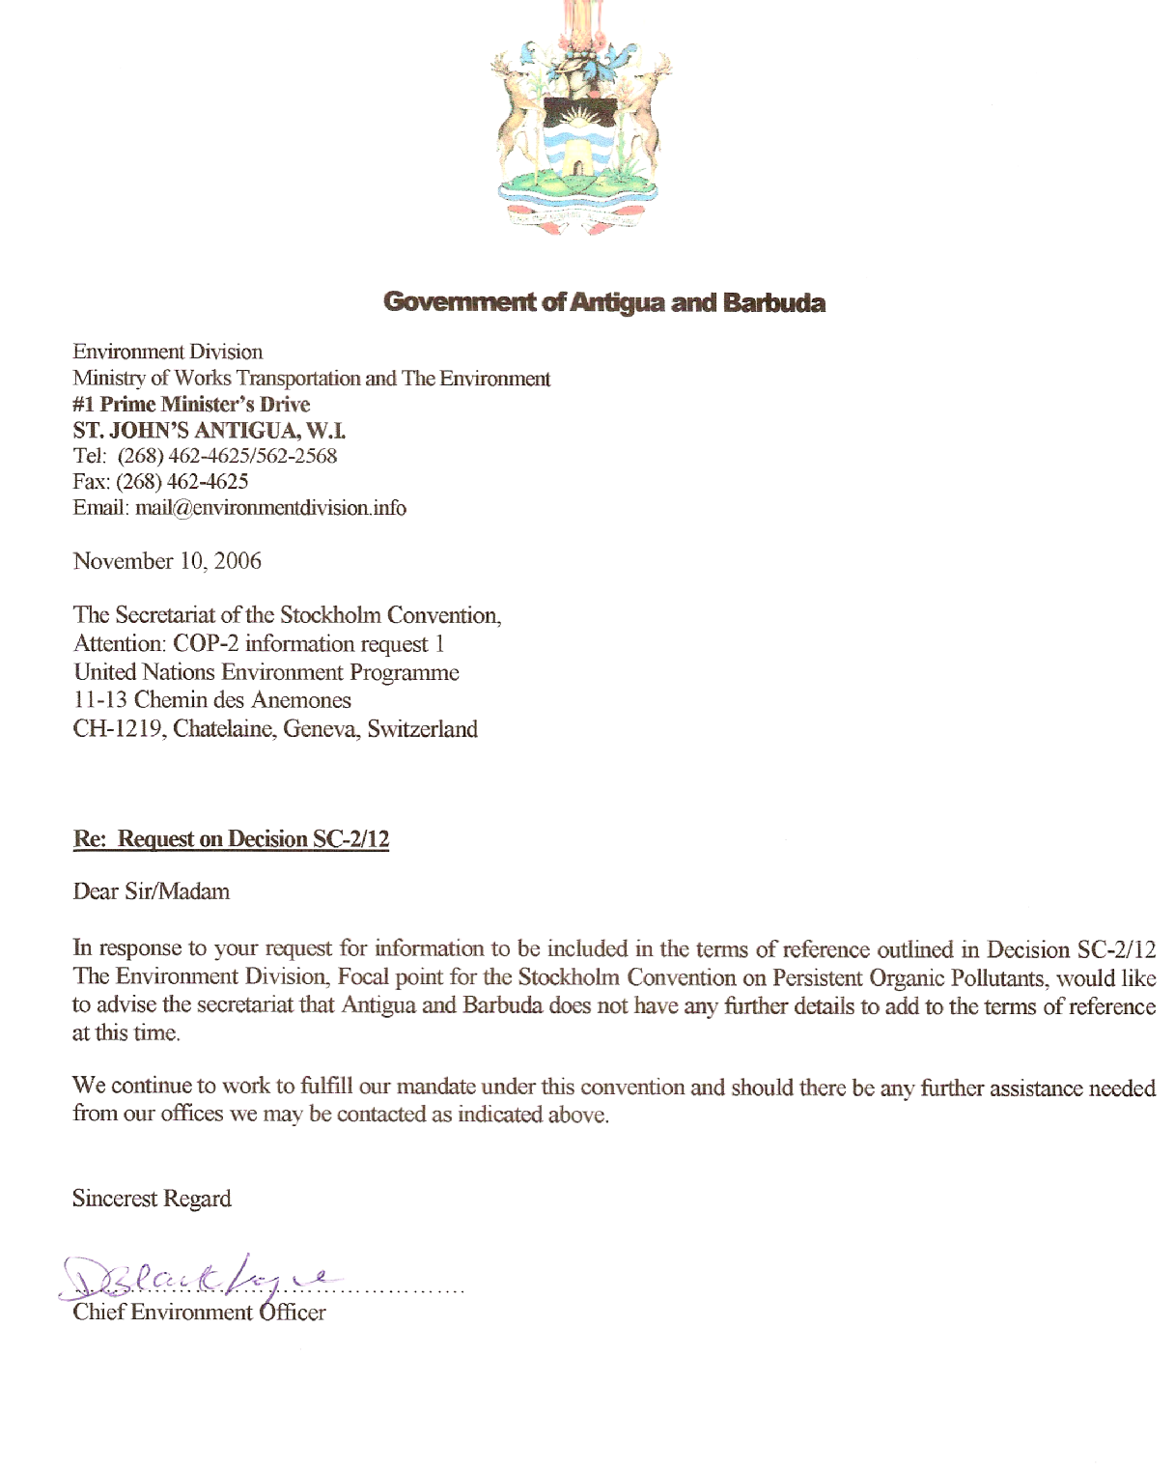

Submission by Burundi

REPUBLIQUE DU BURUNDI

Suite donnée aux décisions adoptées par la Conférence des Parties à la Convention de Stockholm lors de sa 2ème réunion

Demande 4 relative à la décision SC-2/12, paragraphe 5

Opinion du Burundi sur le développement plus approfondi du mandat relatif au travail sur l’évaluation des besoins financiers des Parties qui sont des Pays en développement ou à économie en transition pour la mise en œuvre des dispositions de la Convention durant la période 2006-2010.
- Certains besoins des Pays en développement dont le Burundi, en particulier le matériel et équipements nécessaires pour la réduction des POPs, sont difficiles à évaluer leurs coûts. D’où les pays ont besoin d’une expertise pour estimer correctement les coûts de ces besoins.
- Des stages de formation de courte durée en matière d’évaluation des besoins sont nécessaires pour les Pays en développement et à économie de transition pour renforcer les capacités nationales en la matière.
- Avant d’être présenté à la 3ème réunion de la Conférence des Parties à la Convention de Stockholm, le rapport de l’évaluation préliminaire des besoins devrait être discuté et approuvé par une réunion préparatoire des représentants des Parties.

Submission by China
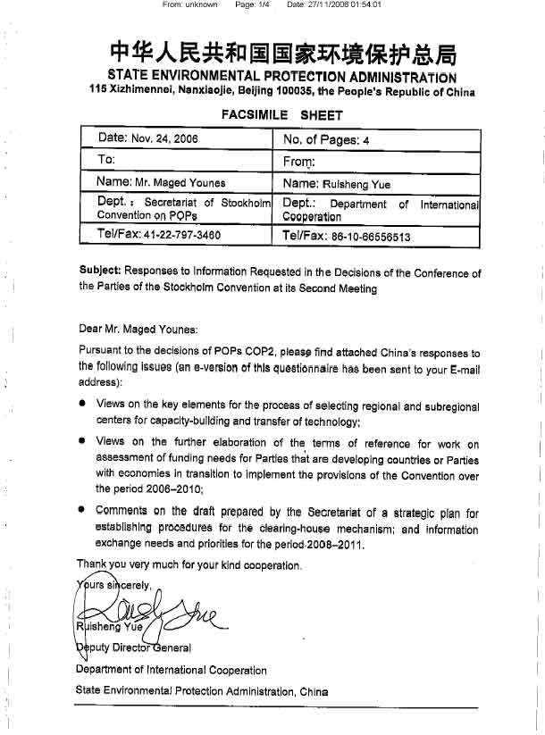
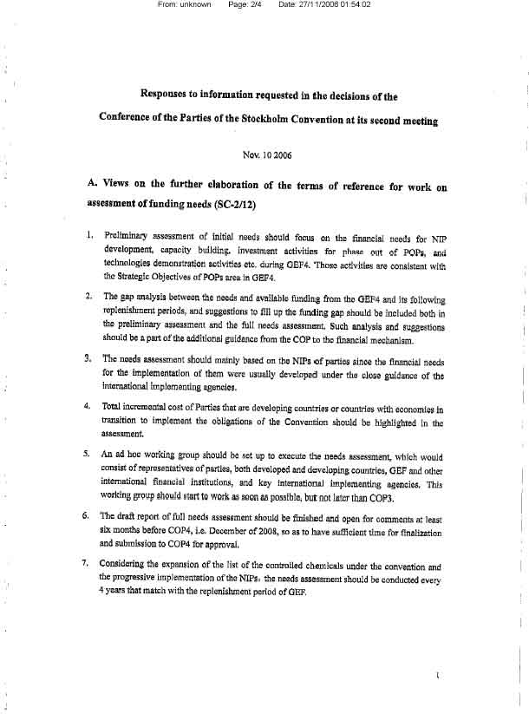

Submission by Slovakia

MINISTRY OF THE ENVIRONMENT OF THE SLOVAK REPUBLIC
Department of the Integrated Pollution Prevention and Control

Nám. Ľudovíta Štúra 1, 812 35 BRATISLAVA 1

Ms. Maged Younes
ssc@pops.int

Your letter/from Our number Prepared by/link Bratislava
Letter/22.6.2006 36080/2006 Ing.Fratričová/+421-2-59562385 24.10.2006

Issue
Implementation of the Stockholm convention on POPs – answer regarding Request 4

Dear Ms Younes,

On the base your letter from 22 June 2006 regarding the next work based on the COP-2 of the Stockholm Convention on Persistent Organic Pollutants (POPs) in conjunction with your request 4 focused in the field of the communication regarding the further elaboration of the ToR for work on assessment of funding needs for Parties to implement the provision of the Stockholm Convention over the period 2006 – 2010 we would like to advice you following statement:
Based on the consultation with relevant national experts with the experience from the area of the co-operation at the existing Regional Centre of the Basel Convention at Slovak Environmental Agency we propose following activities:

- to create the database of the National focal points from the relevant region
- to prepare the questionnaire with the aim to recognise relevant information
- to prepare special letter to all National focal points from the relevant region concerning the identification of the national and regional problems and priorities
- to summarize the results of above mentioned activities
- to prepare review of the relevant needed measures for supporting in relevant region
- to ensure the inventory of the disposal facilities at appropriate level in relevant region
- to ensure the inventory of the facilities with un-POPs
- to propose relevant regional or sub-regional workshops

With best regards

Prepared by Ing. Marta Fratričová from the Department of the IPPC at the MoE of the SR
Approved by Ing. Silvia Uličná, Head of the Department of the IPPC at the MoE of the SR

_______________________

* UNEP/POPS/COP.3/1.
** Stockholm Convention on Persistent Organic Pollutants, Article 13, paragraphs 7 (d) and 7 (e); reports on the work of the Conference of the Parties of the Stockholm Convention at its first meeting (UNEP/POPS/COP.1/31), annex I, decision SC-1/17 and on the work at its second meeting (UNEP/POPS/COP.2/30), annex I, decision SC-2/12.

