UNITED  NATIONS |  |  | SC
 |  | UNEP/POPS/COP.3/INF/27
 | United Nations  Environment  Programme | Distr.: General  11 April 2007  English only

Conference of the Parties of the Stockholm
Convention on Persistent Organic Pollutants
Third meeting
Dakar, 30 April–4 May 2007
Item 5 (b) (ii) of the provisional agenda*
Matters for consideration or action by the Conference of the Parties:
measures to reduce or eliminate releases from unintentional production:
identification and quantification of releases

World Health Organization re-evaluation of dioxin toxic equivalency factors
Note by the Secretariat
The annex to the present note contains information on the World Health Organization re-evaluation of dioxin toxic equivalency factors. The information is being circulated as submitted by the secretariat of the World Health Organization and had not been formally edited.



WHO Re-evaluation of Dioxin Toxic Equivalency Factors

Background

In the Stockholm Convention, Annex C, Part IV: Definitions, it is stated that:

‘The toxic equivalency factor values to be used for the purposes of this Convention shall be consistent with accepted international standards, commencing with the World Health Organization 1998 mammalian toxic equivalency factor values for polychlorinated dibenzo-p-dioxins and dibenzofurans and coplanar polychlorinated biphenyls.’

Over the last 15 years, WHO through the International Programme on Chemical Safety (IPCS) has established and regularly re-evaluated Toxic Equivalency Factors (TEFs) for dioxins and related compounds through expert consultations. WHO-TEF values have been established for humans and mammals, birds and fish. These international-consensus TEFs have been developed to allow assessment and management of complex mixtures of these related and co-occurring compounds. The WHO-TEF scheme has been adopted formally by a number of countries and supranational bodies for monitoring and regulatory purposes.

WHO re-evaluation of TEFs

At the last assessment in 1997 by a WHO expert consultation in Stockholm, it was agreed to re-evaluate TEF values on a regular basis. To follow up on this recommendation, an expert workshop was held in June 2005 at WHO Headquarters in Geneva. A Public Session was held immediately preceding the workshop to give interested parties an opportunity to express their views.

At the workshop itself, an extensive review was performed and each TEF value considered in the light of new data, which led to the revision of a number of values. The table attached lists the TEF values for all 29 congeners currently included in the TEF scheme. The new 2005 WHO-TEF values are given as well as the previous 1998 WHO-TEF values for comparative purposes.

Implication of changes

The expert group examined the implication of the changes in the TEF values on a few case examples and, in general, application of the 2005 TEF values will lead to a slight decrease in total Toxic Equivalents (TEQs) compared to application of the 1998 TEF values.

WHO recommendation

The 2005 WHO dioxin TEFs are based on the latest scientific information available at the time of the review and supersede the 1998 values. WHO recommends that countries note and, where applicable, implement usage of the new WHO 2005 TEF values to replace the previous TEF scheme, consistent with Annex C of the Stockholm Convention referred to above.

For more details please refer to the WHO website at: http://www.who.int/ipcs/assessment/tef_update/en/index.html.

The outcome of the expert workshop has been published as a scientific review paper:
Van den Berg et al., TOXICOLOGICAL SCIENCES 93(2), 223–241 (2006).
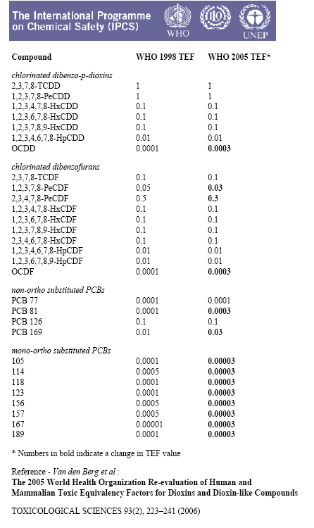

____________________

* UNEP/POPS/COP.3/1.

