UNITED  NATIONS |  |  | SC
 |  | UNEP/POPS/COP.3/INF/28
 | United Nations  Environment  Programme | Distr.: General  13 April 2007  English only

Conference of the Parties of the Stockholm
Convention on Persistent Organic Pollutants
Third meeting
Dakar, 30 April–4 May 2007
Item 5 (c) of the provisional agenda*
Matters for consideration or action by the Conference of the Parties:
measures to reduce or eliminate releases from wastes

Submission by the Secretariat of the Basel Convention of technical guidelines for the environmentally sound management of persistent organic pollutants as wastes
Note by the Secretariat
The annex to the present note contains a letter from the Executive Secretary of the Basel Convention on the Control of Transboundary Movements of Hazardous Wastes and Their Disposal, Ms. Sachiko Kuwabara-Yamamoto, on the submission of technical guidelines for the environmentally sound management of persistent organic pollutants as wastes. The technical guidelines referred to in the letter are reproduced in document UNEP/POPS/COP.3/INF/7 and considered in document UNEP/POPS/COP.3/9. The letter is being circulated as submitted by the Secretariat of the Basel Convention and has not been formally edited.

Annex
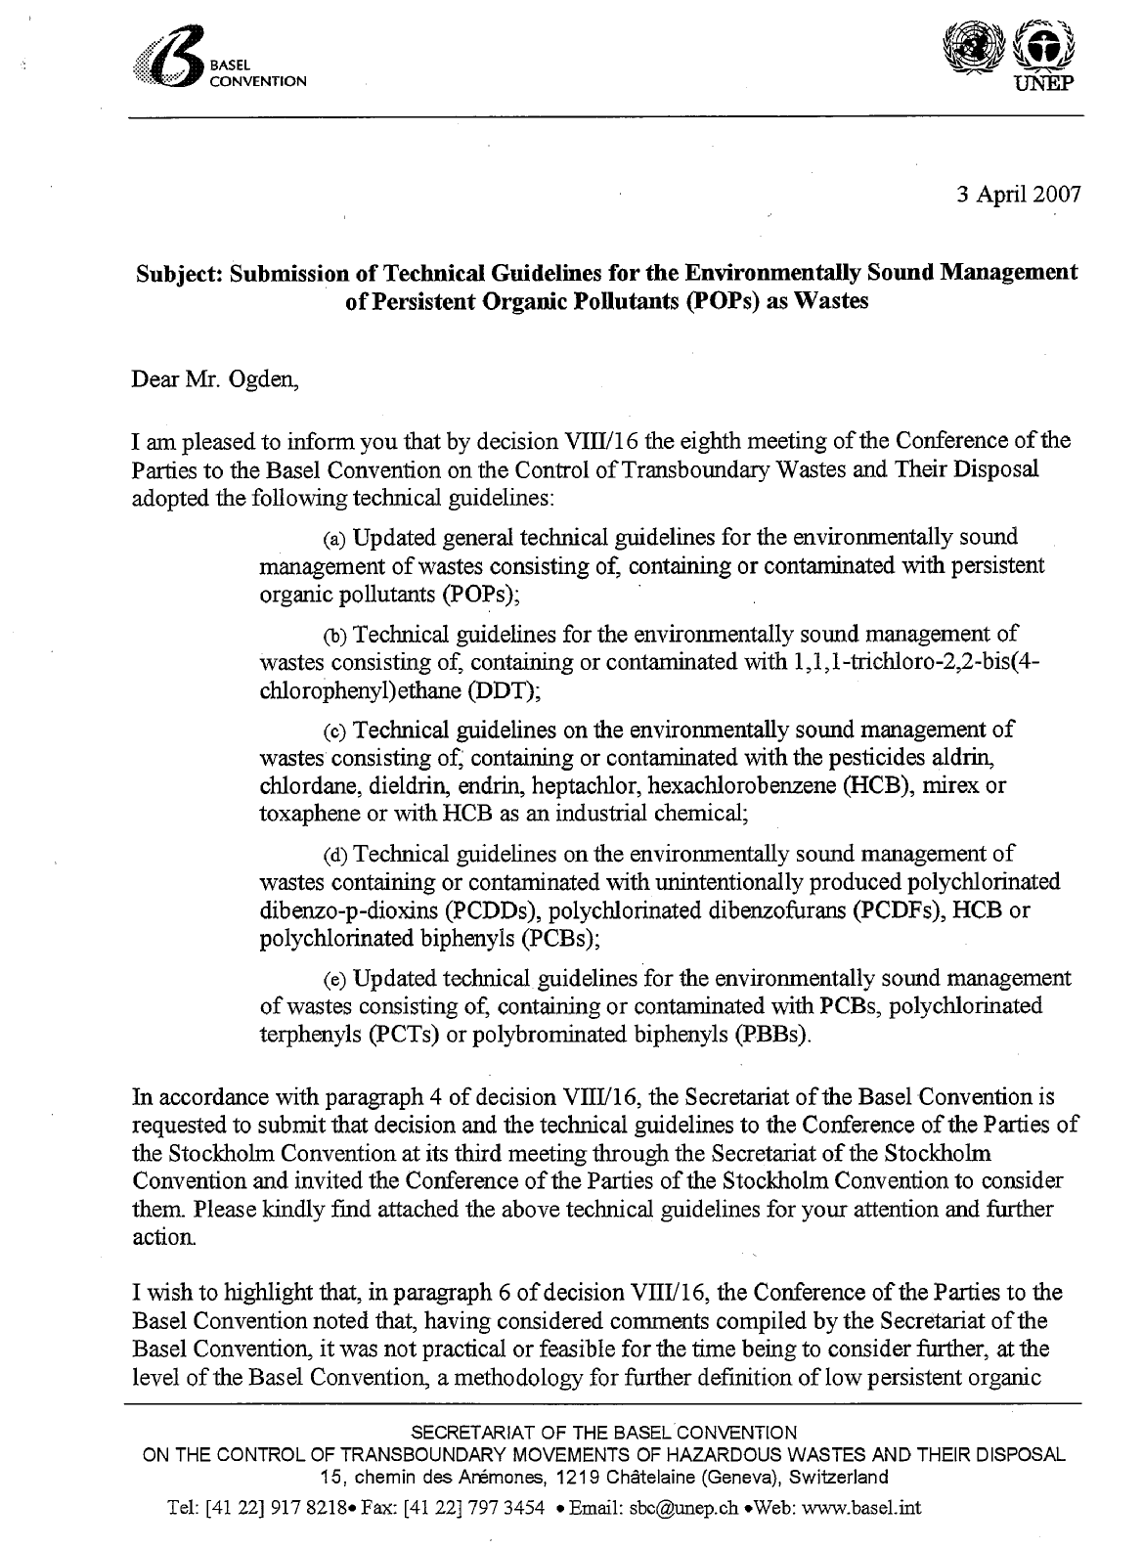
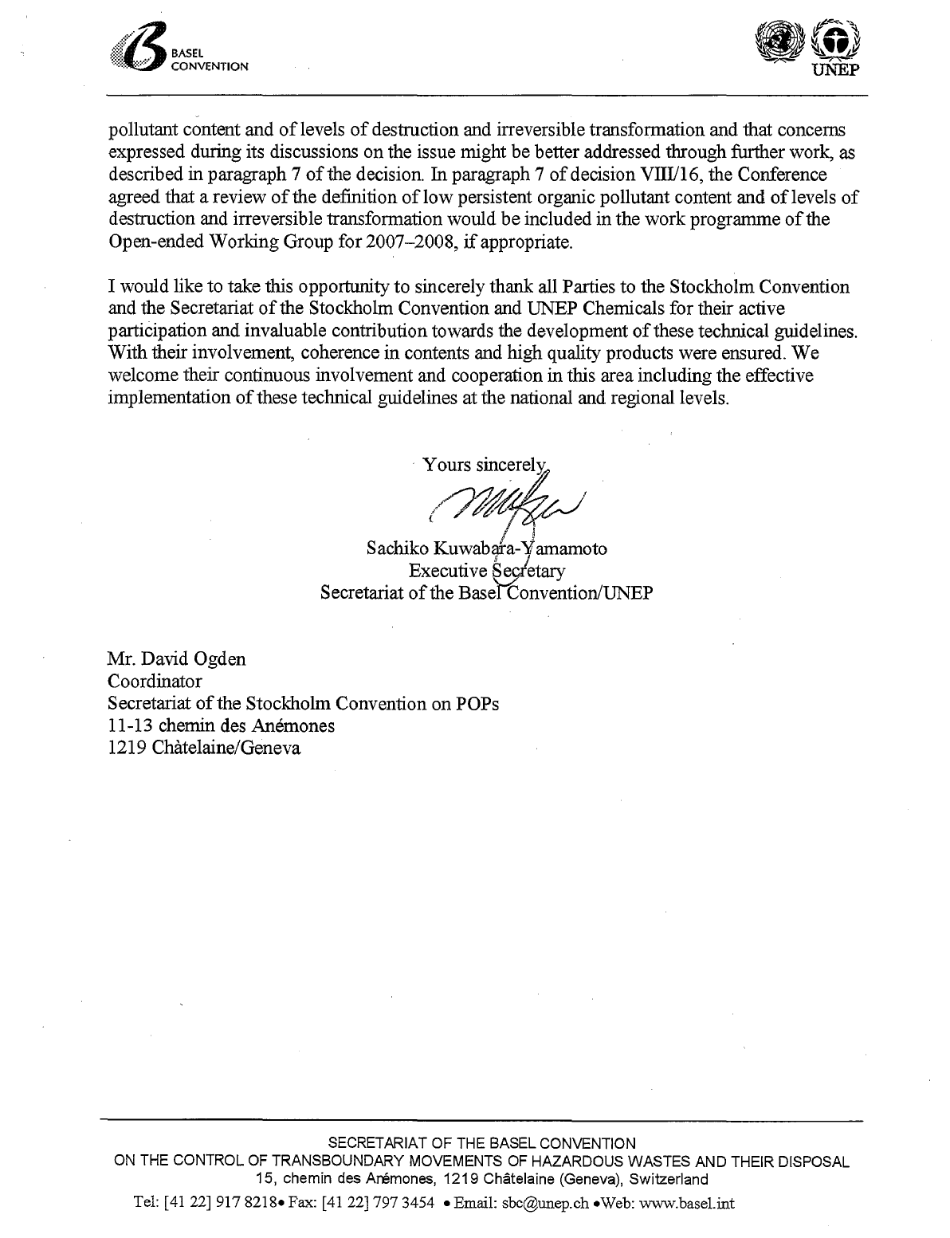

_____________________

* UNEP/POPS/COP.3/1.

