UNITED  NATIONS |  |  | SC
 |  | UNEP/POPS/COP.3/INF/5
 | United Nations  Environment  Programme | Distr.: General  28 February 2007  English only

Conference of the Parties of the Stockholm
Convention on Persistent Organic Pollutants
Third meeting
Dakar, 30 April–4 May 2007
Item 5 (g) of the provisional agenda*
Matters for consideration or action by the
Conference of the Parties: technical assistance

Compilation of submissions received by the Secretariat on the draft terms of reference for selecting regional and subregional centres for capacity–building and the transfer of technology under the Stockholm Convention**
Note by the Secretariat
- By paragraph 4 of its decision SC-2/9, the Conference of the Parties requested the Secretariat to develop draft terms of reference for the process of selecting regional and subregional centres for capacity-building and transfer of technology for consideration by the Conference of the Parties at its third meeting. In undertaking that task, the Secretariat was requested to consult with Stockholm Convention contact points and with the existing regional and subregional centres and their host organizations that provide technical assistance and technology transfer with respect to chemicals and wastes issues.
- In the course of that consultation, the Secretariat received submissions from the following Parties to the Convention: Antigua and Barbuda, Brazil, China, Norway and Slovakia. Those submissions have been reproduced in annex to the present note without formal editing.
Annex

Submission by Antigua and Barbuda
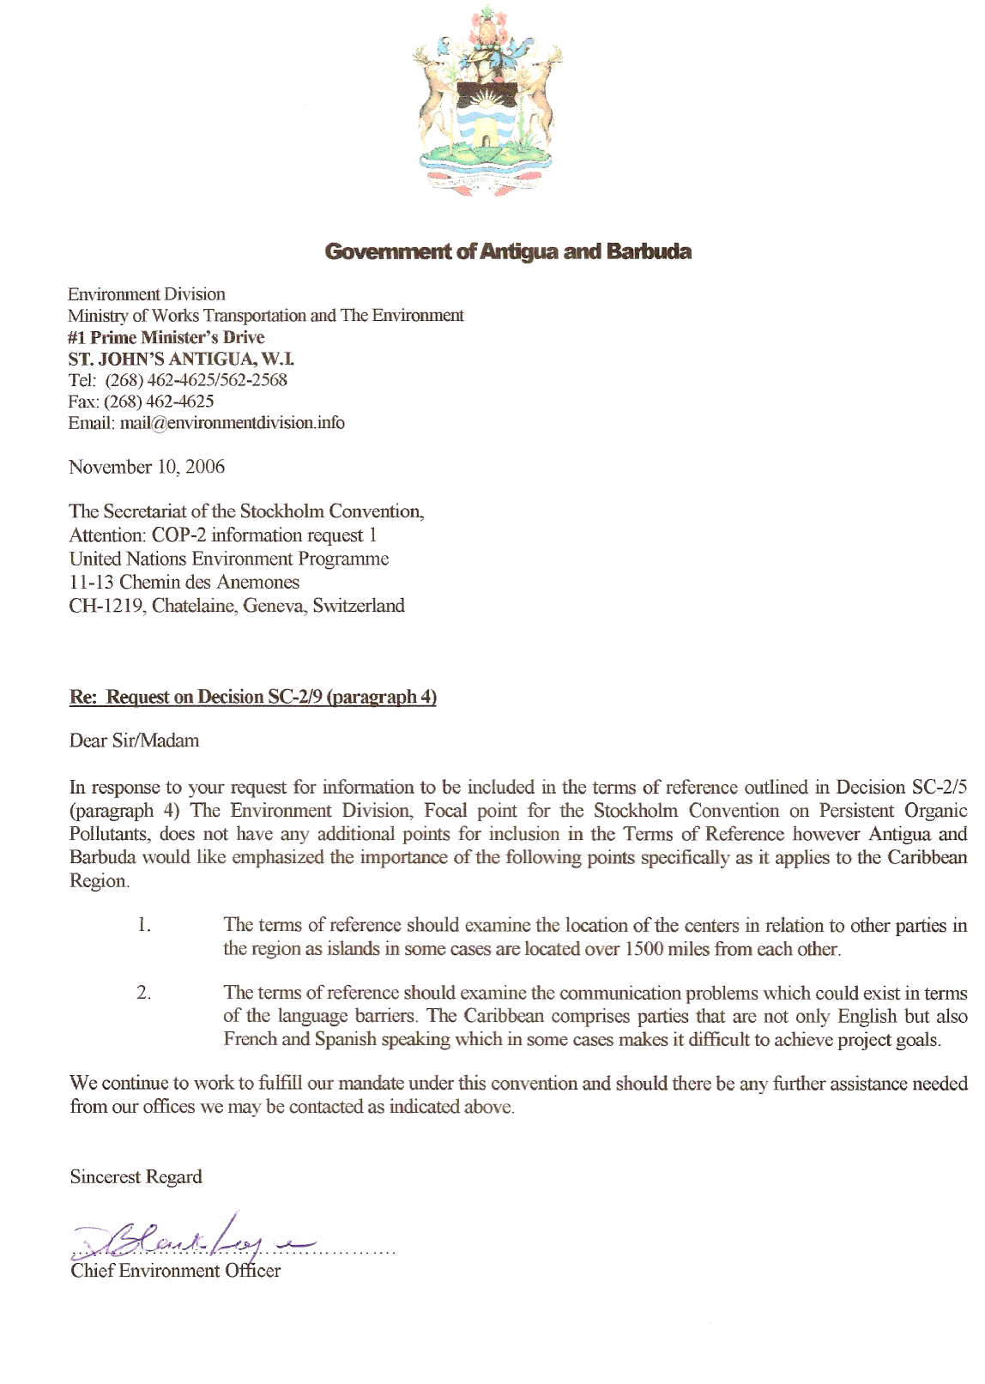
Submission by Brazil

Subject: Follow up to decision SC-2/9 on technical assistance: views on key elements to be included in the terms of reference for the process of selecting regional and subregional centers for capacity-building and transfer of technology.

Considering the request from the Secretariat of the Stockholm Convention on technical assistance, the Brazilian Government believes that the following elements should be taken into account for the selection of regional and subregional centers for capacity-building and transfer of technology:

- Previous experience in technical assistance, capacity building, consulting and technology transfer, at the regional level, in the area of environmentally sound chemicals management;
- Experience in the management and dissemination of information in the area of management of hazardous chemicals and chemical wastes, particularly in raising public awareness with regard to the risks caused by hazardous chemicals;
- Installed and established infrastructure, with laboratory capacity for analyzing wastes, particularly persistent organic pollutants (POPs), development of laboratory procedure: analytical data control, testing methods;
- The institution should be capable of providing training sessions, own computers, telephones and other basic means of communication, suitable meeting rooms and provide for visitor safety;
- Capacity to develop exchange programmes (students, professors, specialists), fellowship programmes;
- Highly qualified technical personnel, with recognized competence in the area of action of the Convention;
- Capacity of communicating in English;
- Capacity to identify, document and implement actions and practices that help the region to promote the environmentally sound management of its hazardous wastes, particularly POPs;
- Experience in the identification, inventorying and cleaning of contaminated areas, particularly with POPs;
- Experience in the application and monitoring of legislation involving hazardous chemical wastes;
- Accredited at Standards and Quality Institutions;
- Stable organizational structure and experience in the mobilization of financial resources in order to ensure implementation of projects and programs with financial feasibility and sustainability;
- Experience in the development of partnerships and technical, scientific and financial cooperation agreements with public and private institutions, national and international non-governmental organizations;
- Renowned excellence in the region in the issues covered by the Convention;
- Institutional responsibility with the Convention obligations, while they remain government commitments;
- Knowledge and practice in the use and promotion of Best Available Techniques and Best Environmental Practices (BAT/BEP);
- Strategic location in the region in order to ensure ease of access and suitable infrastructure conditions (international airport close to the center, electricity, telephone, internet access, banking services, good accommodation in hotels, medical services);
- Centers should have renowned technical competence, with highly qualified personnel, capable of providing scientific support to technical assistance projects and programs in the area of the Convention and other environment related agreements that are of interest to the region.

Submission by China 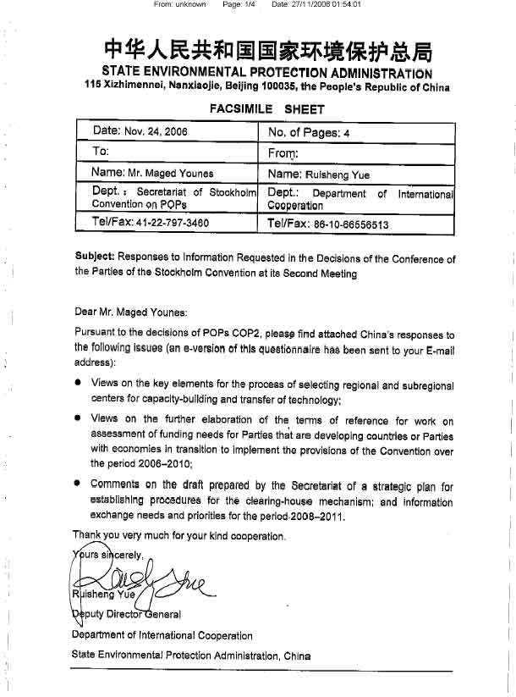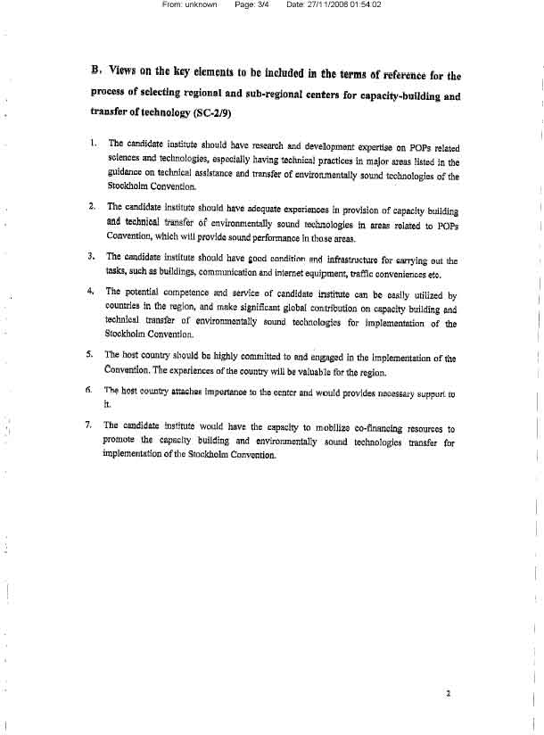

Submission by Norway

Follow up to the decisions taken by the Conference of the Parties of the Stockholm Convention at its second meeting - comments from Norway to request 3 and 8 from the Secretariat
Request 3: Decision SC-2/9 Technical assistance (paragraph 4)
Norway wants to emphasise the importance of an effective process to select centres that meet the criteria in the terms of reference decided by COP2 (Annex I to decision SC-2/9). The importance of synergies with existing centres, in particular the centres of the Basel Convention, should be stressed in the process of selecting regional and subregional centres for capacity-building and transfer of technology. The terms of reference for the process of selecting regional and subregional centres therefore should explicitly promote synergies and co-operation in administrative tasks and programmes in the conventions on chemicals and hazardous wastes. This could be done by stating the identification of synergies and co-operative elements as a necessary step in the selection process. A rule of preference for centres in other relevant conventions, all other things being equal, could also be a part of these terms of reference.

Submission by Slovakia

MINISTRY OF THE ENVIRONMENT OF THE SLOVAK REPUBLIC
Department of the Integrated Pollution Prevention and Control

Nám. Ľudovíta Štúra 1, 812 35 BRATISLAVA 1

Ms. Maged Younes
ssc@pops.int

Your letter/from Our number Prepared by/link Bratislava
Letter/22.6.2006 36076/2006 Ing.Fratričová/+421-2-59562385 23.10.2006

Issue
Implementation of the Stockholm convention on POPs – answer regarding Request 3

Dear Ms Younes,

On the base your letter from 22 June 2006 regarding the next work based on the COP-2 of the Stockholm Convention on Persistent Organic Pollutants (POPs) in conjunction with your request 3 focused in the field of the communication regarding the key elements to be included in the terms of reference for the process of selecting regional by the Conference of the Parties at its third meeting we would like to advice you following statement:
Based on the consultation with relevant national experts with the experience from the area of the co-operation at the existing Regional Centre of the Basel Convention at Slovak Environmental Agency we propose following activities:
- review of the existing professional background with the connection to requested synergy
- practical experiences with the relevant work in the region
- realisation of the long-term and short-term (workshops) regional projects
- to be fully equipped with the necessary personal computers, with installed updated software, with installed and operational communication facilities including telephone and fax lines and reliable internet connections
- highly qualified technical personnel
- separate bank account
- institutional background
- to be able to identify the regional priorities
- to declare the efficiency and effectiveness in the field of capacity building and technology transfer
- to be able to provide technical assistance and dissemination of information
- national legislation database creation, national implementation plans
- national focal points database creation
- co-operation with others SCRC, MEAs
- co-operation with regional NGOs
- preparation and submission of requested documents – professional and financial – based on COP SC decisions or donor institutions
- projects co-ordination

With best regards

Prepared by Ing. Marta Fratričová from the Department of the IPPC at the MoE of the SR
Approved by Ing. Silvia Uličná, Head of the Department of the IPPC at the MoE of the SR
______________________

* UNEP/POPS/COP.3/1.
** Stockholm Convention on Persistent Organic Pollutants, Article 12; reports on the work of the Conference of the Parties of the Stockholm Convention at its first meeting (UNEP/POPS/COP.1/31), annex I, decision SC-1/15 and at its second meeting (UNEP/POPS/COP.2/30), annex I, decision SC-2/9.

