UNITED  NATIONS | EP

  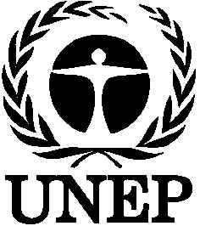 | United Nations  Environment  Programme | Distr.  GENERAL  UNEP/POPS/INC.2/1  21 October 1998  ORIGINAL: ENGLISH
INTERGOVERNMENTAL NEGOTIATING COMMITTEE FOR AN
INTERNATIONAL LEGALLY BINDING INSTRUMENT FOR
IMPLEMENTING INTERNATIONAL ACTION ON
CERTAIN PERSITENT ORGANIC POLLUTANTS
Second session
Nairobi, 25-29 January 1999

PROVISIONAL AGENDA
1. Opening of the session.
2. Organizational matters:
(a) Adoption of the agenda;
(b) Organization of work;
(c) Report by the secretariat on inter-sessional work requested by the Committee.
3. Review of ongoing international activities relating to the work of the Committee.
4. Report of the Criteria Expert Group.
5. Preparation of an international legally binding instrument for implementing international action on certain persistent organic pollutants.
6. Other matters.
7. Adoption of the report.
8. Closure of the session.

