UNITED  NATIONS | EP

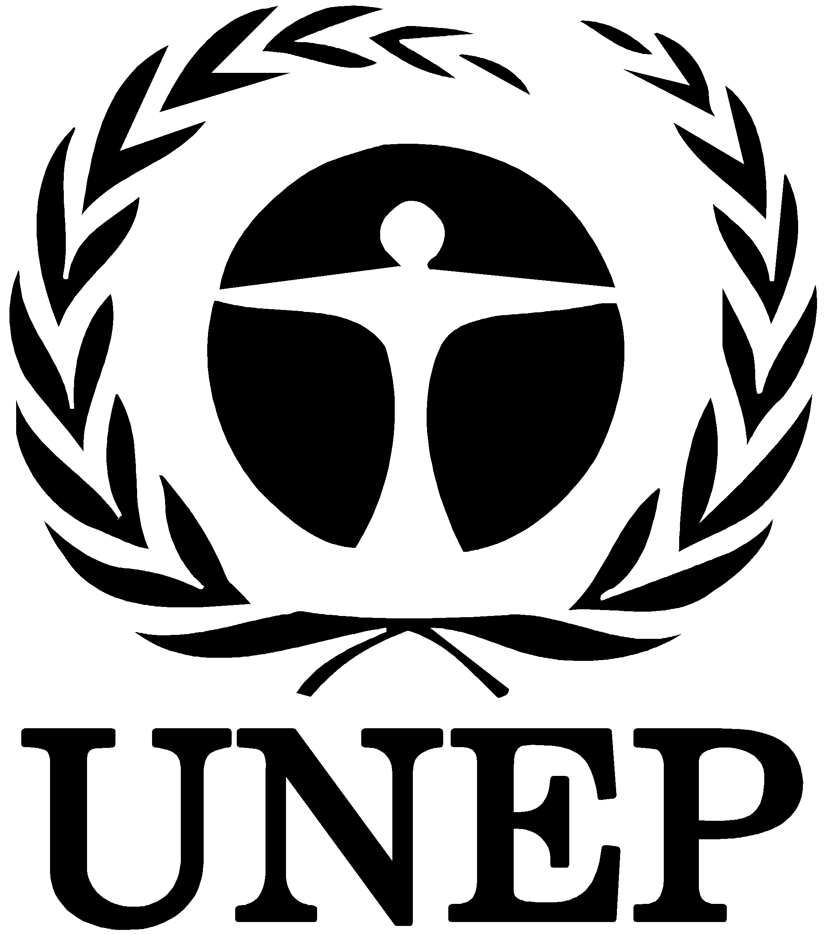 | United Nations  Environment  Programme | Distr.  GENERAL  UNEP/POPS/INC.2/3  26 November 1998  ORIGINAL: ENGLISH
INTERGOVERNMENTAL NEGOTIATING COMMITTEE FOR AN
INTERNATIONAL LEGALLY BINDING INSTRUMENT FOR
IMPLEMENTING INTERNATIONAL ACTION ON
CERTAIN PERSITENT ORGANIC POLLUTANTS
Second session
Nairobi, 25-29 January 1999

Possible capacity-building activities and their associated costs
under the international legally binding instrument for
implementing international action on certain
persistent organic pollutants - brief summary
Note by the Secretariat
1. At its first session, the Intergovernmental Negotiating Committee asked the Secretariat to prepare a number of documents pertaining to technical and financial assistance for consideration at its second session. Among the documents requested was "a preliminary review of information on possible costs associated with potential areas of technical and financial assistance that could be associated with an international legally binding instrument for implementing international action on POPs". The Committee noted that the document to be submitted to it at its second session would be preliminary in nature and would be updated as the Secretariat obtained more information (UNEP/POPS/INC.1/7, para. 62 (b)).
2. In response to this request, the Secretariat conducted a preliminary review of possible capacity-building activities and their associated costs under an international legally binding instrument for implementing international action on certain persistent organic pollutants. This material appears in the information document UNEP/POPS/INC.2/INF/3; a brief summary is provided below. The content of UNEP/POPS/INC.2/INF/3 will be modified over the course of the negotiations as new information becomes available, and hence it does not provide an exhaustive list of capacity-building activities. The final form and content of the POPs instrument will ultimately dictate exactly what activities will be needed.
3. The following is a brief description of each of the eight activity areas identified in UNEP/POPS/INC.2/INF/3:
(a) Development of a country inventory describing the present situation with regard to production, imports, exports, stocks, environmental releases, use and disposal of each of the POPs;
(b) Development of an action plan that provides a comprehensive strategy for complying with the obligations of a POPs convention. This plan could be based on the information in the country inventory and could serve as a priority-setting tool for initiating future activities on POPs;
(c) Establishment of a POPs focal unit within each Government. The unit would serve as a primary point of contact for POPs-related issues among various ministries with responsibilities or authority involving POPs assessment, management or elimination;
(d) Development and implementation of regulatory controls to achieve compliance with the POPs convention;
(e) Development and strengthening of enforcement capacities to ensure compliance with regulatory controls in response to POPs convention obligations;
(f) Implementation of technology transfer activities targeted at key sectors with the goal of introducing technologies that would assist countries in meeting POPs convention obligations;
(g) Enhancement of local commerce infrastructure for distributing alternative technologies to ensure that both products and local support services are widely available.
(h) Development of an outreach/information programme to educate the public and industry about the potential risks arising from the presence of POPs in their environment, and the national and international responses to address them.
4. The estimated costs of implementing the activities listed above are summarized in table 1 of UNEP/POPS/INC.2/INF/3.

-----

