UNITED
EP
NATIONS
United Nations
Environment
Programme

Distr.
GENERAL

UNEP/POPS/INC.4/INF/5
3 March 2000

ENGLISH ONLY

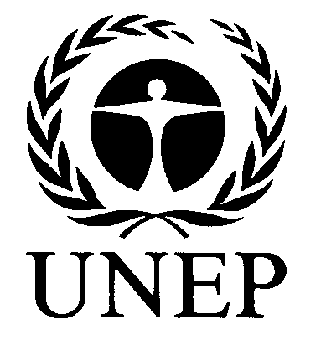
INTERGOVERNMENTAL NEGOTIATING COMMITTEE FOR AN
INTERNATIONAL LEGALLY BINDING INSTRUMENT
FOR IMPLEMENTING INTERNATIONAL ACTION ON
CERTAIN PERSISTENT ORGANIC POLLUTANTS
Fourth meeting
Bonn, 20-25 March 2000
Item 3 of the provisional agenda∗

REVIEW OF ONGOING INTERNATIONAL ACTIVITIES RELATING
TO THE WORK OF THE COMMITTEE

Master list of actions on the reduction and/or elimination
of the releases of persistent organic pollutants

Note by the secretariat

1. As noted by the secretariat at the second session of the Intergovernmental Negotiating Committee, many countries and organizations are actively involved in activities dealing with persistent organic pollutants (POPs). To avoid duplication of efforts and ensure an efficient use of resources, while facilitating coordination and cooperation among countries and organizations involved in related activities at the national, regional and international levels, the United Nations Environment Programme (UNEP) considered it valuable to draw up a master list of actions on the reduction and/or elimination of the release of POPs.

2. An initial description of such a list, along with a preliminary listing of some activities, was provided in document UNEP/POPS/INC.2/INF/8. The first complete edition of the master list of actions on the reduction and/or elimination of the releases of persistent organic pollutants was made available at the third session of the Committee as document UNEP/POPS/INC.3/INF/9.

3. To collect information for this second edition of the master list, a letter was sent on 8 October 1999 to UNEP POPs focal points and to UNEP official contact points in countries that have not yet established UNEP POPs focal points. This second edition incorporates responses to the letter received by the secretariat by 31 December 1999.

-----

- UNEP/POPS/INC.4/1.

