UNITED  NATIONS |  |  | SC
 |  | UNEP/POPS/POPRC.1/INF/3
 | United Nations  Environment  Programme | Distr.: General  24 August 2005  English only

Stockholm Convention on Persistent Organic Pollutants
Persistent Organic Pollutants Review Committee
First meeting
Geneva, 7–11 November 2005
Item 3 of the provisional agenda*

Review of the role and mandate of the

Persistent Organic Pollutants Review Committee

Procedure for listing chemicals in Annexes A, B and C of the Convention**
Note by the Secretariat

- The annexes to the present note contain, for information, flow charts illustrating the procedures established by Article 8 of the Convention for listing chemicals in Annexes A, B and C of the Convention.
- Annex I contains a simplified flow chart illustrating the procedure to be employed when the Committee does not set aside a proposal at any time. Annex II contains the full procedure, including the options available when the Committee sets aside a proposal.
- The annexes have not been formally edited.

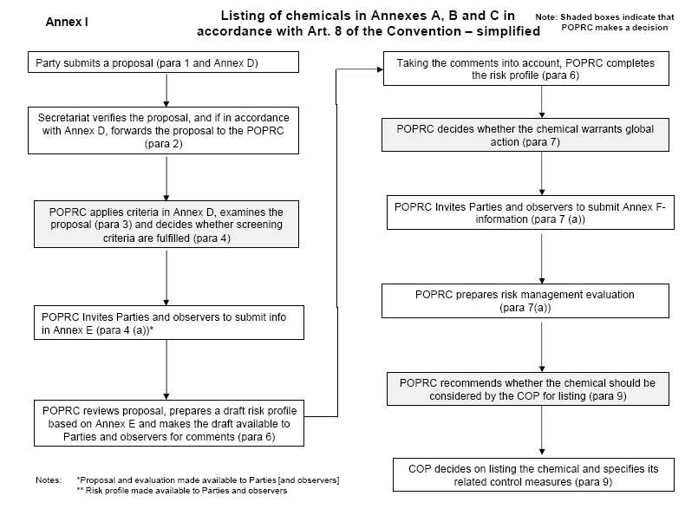
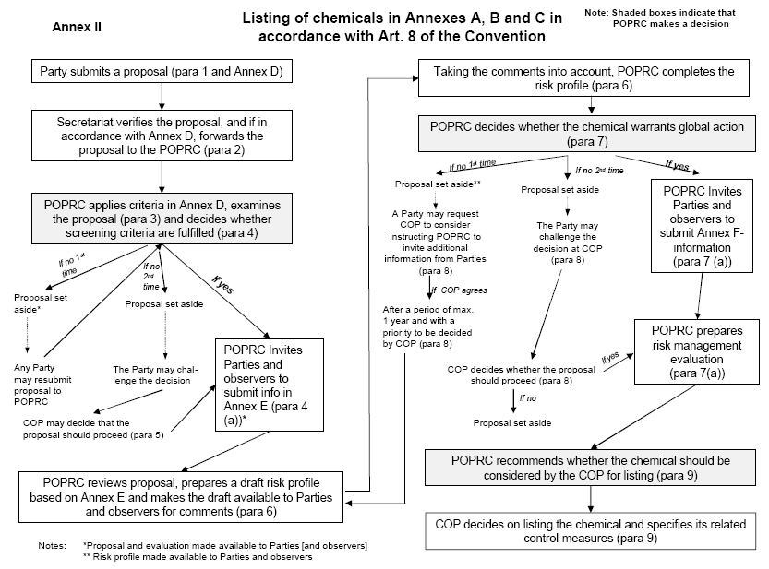
_____________________

* UNEP/POPS/POPRC.1/1.
** Stockholm Convention, Article 8.

