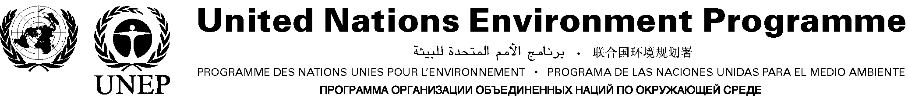
For use of the media only;
not an official document.

PRESS RELEASE

Stockholm Convention on POPs to become
international law, launching a global campaign
to eliminate 12 hazardous chemicals

Stockholm, 14 May 2004 – The 2001 Stockholm Convention on Persistent Organic Pollutants (POPs) enters into force on Monday, May 17, marking the start of an ambitious international effort to rid the world of PCBs, dioxins and furans, and nine highly dangerous pesticides.

“The Stockholm Convention will save lives and protect the natural environment – particularly in the poorest communities and countries – by banning the production and use of some of the most toxic chemicals known to humankind,” said Executive Klaus Toepfer of the United Nations Environment Programme (UNEP), under whose auspices the Convention was adopted.

“Over the next several years national investments plus donor pledges of hundreds of millions will channel more than five hundred million dollars into an overdue and urgently needed initiative to ensure that future generations do not have to live as we do with measurable quantities of these toxic chemicals stored in their bodies,” he said.

Much of this funding will be managed by the Global Environment Facility, which serves as the financial mechanism for the Convention on an interim basis.

Of all the pollutants released into the environment every year by human activity, POPs are amongst the most dangerous. For decades these highly toxic chemicals have killed and sickened people and animals by causing cancer and damaging the nervous, reproductive and immune systems. They have also caused uncounted birth defects.

Governments will seek a rapid start to action against POPs when they meet for the first meeting of the Conference of the Parties to the Convention (COP 1) in Punta del Este, Uruguay in the first week of May, 2005. They will fast-track efforts to:

- reduce or eliminate the carcinogenic chemicals known as dioxins and furans, which are produced unintentionally as by-products of combustion. Many of the required improvements in technologies and processes may prove expensive and technically challenging, particularly for developing countries.
- assist countries in malarial regions to replace DDT with the increasingly safe and effective alternatives. Until such alternatives are in place, the Convention allows governments to continue using DDT to protect their citizens from malaria – a major killer in many tropical regions.
- support efforts by each national government to develop an implementation plan. Already, over 120 developing countries have started to elaborate such plans with funds from the Global Environment Facility. The COP will also focus on channelling new funds into POPs projects.
- measure and evaluate changes in the levels of POPs in the natural environment and in humans and animals in order to confirm whether the Convention is indeed reducing releases of POPs to the environment.
- establish a POPs review committee for evaluating additional chemicals and pesticides to be added to the initial list of 12 POPs.
- finalize guidelines for promoting “best environmental practices” and “best available techniques” that can reduce and eliminate releases of dioxins and furans.

In addition to banning the use of POPs, the treaty focuses on cleaning up the growing accumulation of unwanted and obsolete stockpiles of pesticides and toxic chemicals that contain POPs. Dump sites and toxic drums from the 1950s, ‘60s, and ‘70s are now decaying and leaching chemicals into the soil and poisoning water resources, wildlife and people. The Convention also requires the disposal of PCBs and PCB-containing wastes.

Every human in the world carries traces of POPs in his or her body. POPs are highly stable compounds that can last for years or decades before breaking down. They circulate globally through a process known as the "grasshopper effect". POPs released in one part of the world can, through a repeated process of evaporation and deposit, be transported through the atmosphere to regions far away from the original source.

Fortunately, there are alternatives to most POPs. The problem has been that high costs, a lack of public awareness, and the absence of appropriate infrastructure and technology have often prevented their adoption. Solutions must be tailored to the specific properties and uses of each chemical, as well as to each country's climatic and socio-economic conditions.

Note to journalists: For additional information, please contact Eric Falt, UNEP Spokesperson, at +254 20 623292, Mobile: +254 (0) 733 682656, or eric.falt@unep.org; Nick Nuttall, UNEP Head of Media at +254 20 623084, Mobile: +254 733 632755, or nick.nuttall@unep.org, or Michael Williams at +41-22-917 8242, +41-79-409 1528 (cell) or michael.williams@unep.ch. See also www.pops.int.

